Machine Learning Basics

Krasimira Kapitanova and Sang H. Son

University of Virginia

The goal of machine learning is to design and develop algorithms that allow systems to use empirical data, experience, and training to evolve and adapt to changes that occur in their environment. A major focus of machine learning research is to automatically induce models, such as rules and patterns, from the training data it analyzes. As shown in Figure 1, machine learning combines techniques and approaches from various areas, including probability and statistics, psychology, information theory, and artificial intelligence.
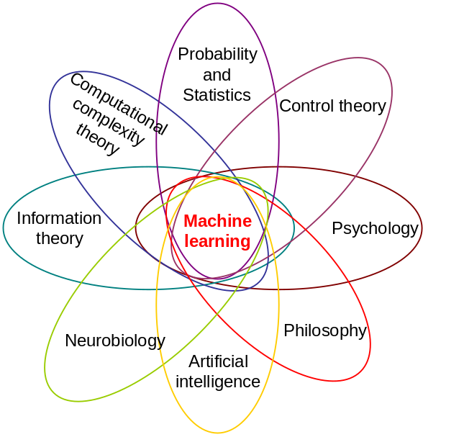
Figure 1: Machine learning is a broad discipline, combining approaches from many different areas.

Wireless sensor network (WSN) applications operate in very challenging conditions, where they constantly have to accommodate environmental changes, hardware degradation, and inaccurate sensor readings. Therefore, in order to maintain sufficient operational correctness, a WSN application often needs to learn and adapt to the changes in its running environment. Machine learning has been used to help address these issues. A number of machine learning algorithms have been employed in a wide range of sensor network applications, including activity recognition, healthcare, education, and improving the efficiency of heating, ventilating, and air conditioning (HVAC) system.

The abundance of machine learning algorithms can be divided into two main classes, supervised and unsupervised learning, based on whether the training data instances are labeled. In supervised learning the learner is supplied with labeled training instances, where both the input and the correct output are given. In unsupervised learning the correct output is not provided with the input. Instead, the learning program must rely on other sources of feedback to determine whether or not it is learning correctly. A third class of machine learning techniques, called semi-supervised learning, uses a combination of both labeled and unlabeled data for training. Figure 2 shows the relationship between these three machine learning classes.
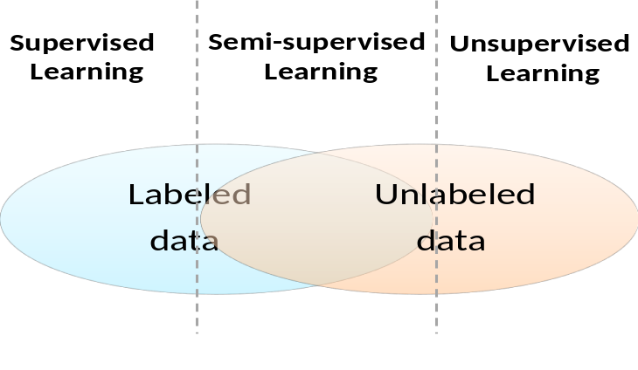
Figure 2: Machine learning algorithms are divided into supervised learning, which used labeled training data, and unsupervised learning, where labeled training data is not available. A third class of machine learning technique, semi-supervised learning, makes use of both labeled and unlabeled training data.
In this chapter we have surveyed machine learning algorithms in sensor networks from the perspective of what types of applications they have been used for. We give examples from all three machine learning classes and discuss how they have been applied in a number of sensor network applications. We present the most frequently used machine learning algorithms, including clustering, Bayes probabilistic models, Markov models, and decision trees. We also analyze the challenges, advantages, and drawbacks of using different machine learning algorithms. Figure 3 shows the machine learning algorithms introduced in this chapter.

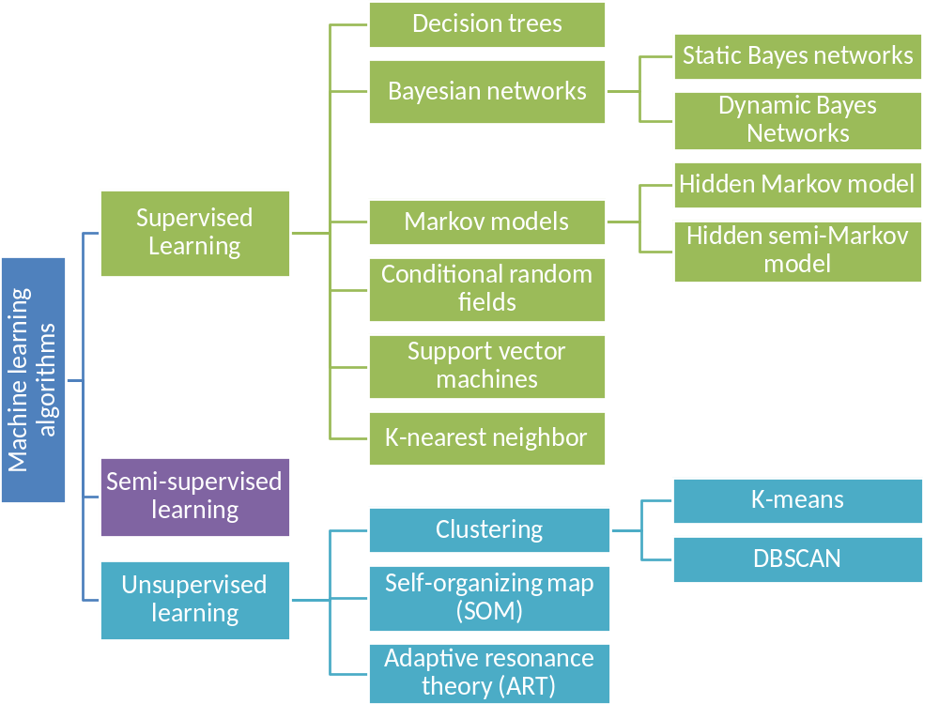
Figure 3: Classification of the machine learning algorithms most widely used in WSN applications.

Supervised Learning
In supervised learning the learner is provided with labeled input data. This data contains a sequence of input/output pairs of the form ‹ x_{i}, y_{i} ›, where x_{i} is a possible input, and y_{i} is the correctly labeled output associated with it. The aim of the learner in supervised learning is to learn the mapping from inputs to outputs. The learning program is expected to learn a function f that accounts for the input/output pairs seen so far, f(x_{i}) = y_{i} for all i. This function f is called a classifier if the output is discrete and a regression function if the output is continuous. The job of the classifier/regression function is to correctly predict the outputs of inputs it has not seen before. For example, the inputs can be a set of sensor firings and the outputs can be the activities that have caused those sensor nodes to fire.

The execution of a supervised learning algorithm can be divided into 5 main steps (Figure 4).

Step 1 is to determine what training data is needed and collect that data. Here we need to answer two questions “What data is necessary?” and “How much of it?”. The designers have to decide what training data can best represent real world scenarios for the specific application. They also need to determine how much training data should be collected. Although the more training data we have, the better we can train the learning algorithm, collecting training data and providing correct labels can often be expensive and laborious. Therefore, an application designer always strives to maintain the size of the training data large enough to provide sufficient training but also small enough to avoid any unnecessary costs associated with data collection and labeling.

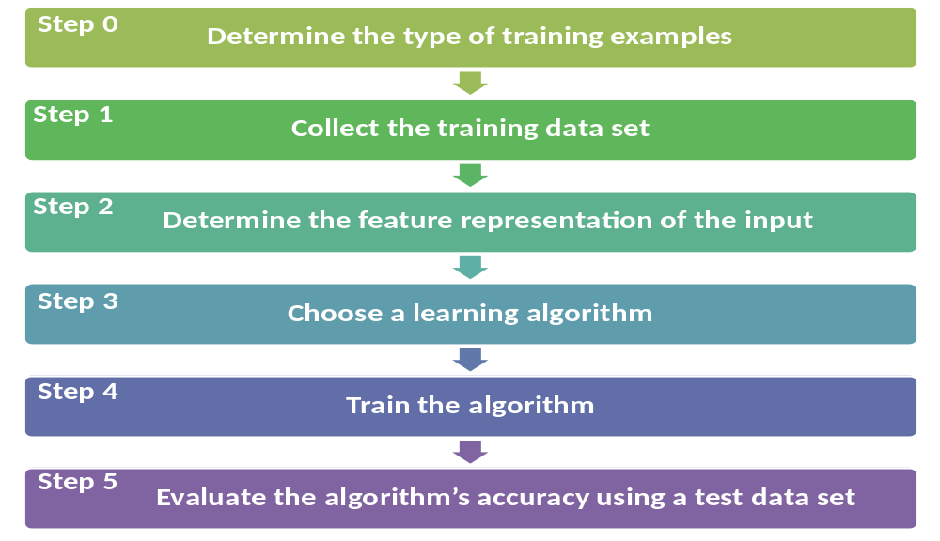
Figure 4: The stages of supervised machine learning.

Step 2 is to identify the feature set, also called feature vector, to be used to represent the input. Each feature in the feature set represents a characteristic of the objects/events that are being classified. There is a trade-off between the size of the feature vector and the classification accuracy of the machine learning algorithm. A large feature vector significantly increases the complexity of the classification. However, using a small feature vector, which does not contain sufficient description of the objects/events, could lead to poor classification accuracy. Therefore, the feature vector should be sufficiently large to represent the important features of the object/event and small enough to avoid excessive complexity.

Step 3 is to select a suitable learning algorithm. A number of factors have to be considered when choosing a learning algorithm for a particular task, including the content and size of the training dataset, noise in the system, accuracy of the labeling, and the heterogeneity and redundancy of the input data. We also have to evaluate the requirements and characteristics of the sensor network application itself. For example, for an activity recognition application the duration of sensor use plays a significant role in determining the activity being executed. Therefore, to achieve high activity recognition accuracy, we would prefer to use machine learning algorithms that can explicitly model state duration.

The most frequently used supervised machine learning algorithms include support vector machines, naïve Bayes classifiers, decision trees, hidden Markov models, conditional random field, and k-nearest neighbor algorithms. There are also a number of approaches that have been applied to improve the performance of the chosen classifiers, such as bagging, boosting, and using classifier ensembles. Each of the algorithms has its advantages and disadvantages, which make it suitable for some types of applications but inappropriate for others.

Step 4 is to train the chosen learning algorithm using the collected training data. In this step the algorithm learns the function that best matches the input / output training instances.

Step 5 is evaluation of the algorithm’s accuracy. We assess the accuracy of the learned function with the help of testing dataset, where the testing dataset is different from the training dataset. In this step we evaluate how accurately the machine learning algorithm classifies entries from the testing set based on the function is has learned though the training dataset.

Different supervised learning algorithms have been used and evaluated experimentally in a variety of sensor network applications. In the rest of this section we describe some of the algorithms that are most frequently used in WSN applications.

Decision trees
Decision trees are characterized by fast execution time, ease in the interpretation of the rules, and scalability for large multi-dimensional datasets (Cabena, et al. 1998), (Han 2005). The goal of decision tree learning is to create a model that predicts the value of the output variable based on the input variables in the feature vector. Each node corresponds to one of the feature vector variables. From every node there are edges to children, where there is an edge per each of the possible values (or range of values) of the input variable associated with the node. Each leaf represents a possible value for the output variable. The output variable is determined by following a path that starts at the root and is guided by the values of the input variables.

Figure 5 shows an example decision tree for a sensor network activity detection application. In this scenario we assume that there are only two events of interest in the kitchen: cooking and getting a drink. The decision tree uses sensor node firings to distinguish between those two activities. For example, if there is movement in the kitchen and the stove is being used, the algorithm determines that the residents must be cooking. However, if there is movement in the kitchen, the stove is not being used, and somebody opens the cups cupboard, the algorithm decides that the activity being performed at the moment is getting a drink. This is a simple example illustrating how decision trees can be applied to sensor network applications. In reality, the decision trees that are learned by real applications are much more complex.
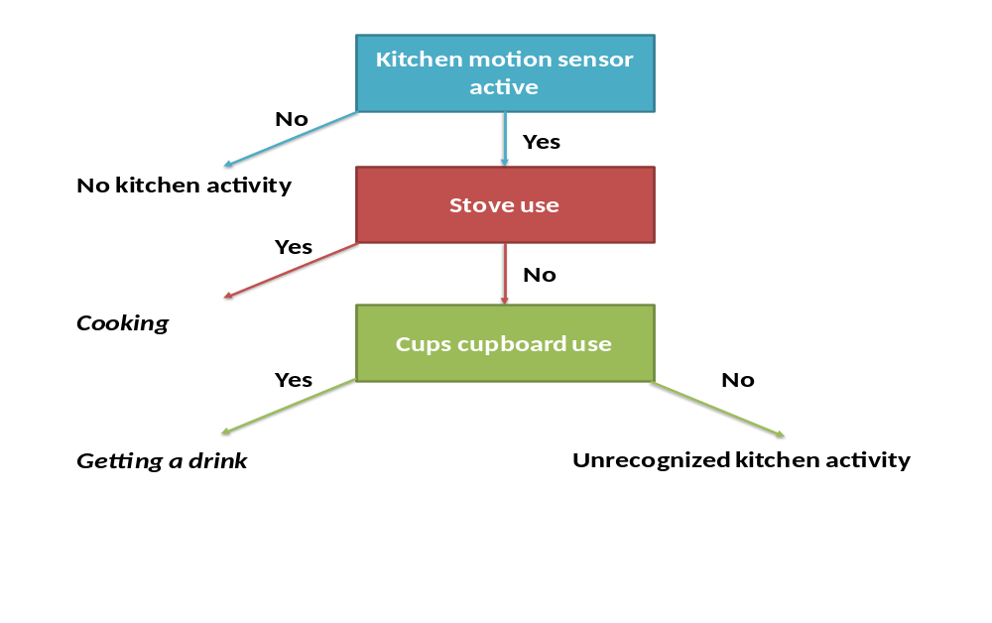
Figure 5: Example decision tree for an activity detection application. In this scenario we are only interested in two of the kitchen activities: cooking and getting a drink. The decision tree is used to determine which one of these activities is currently occurring based on the sensor nodes that are firing in the kitchen.

The C4.5 algorithms is one of the well-known, top-down, greedy search algorithms for building decision trees (Quinlan, C4.5: programs for machine learning 1993). The algorithm uses entropy and information gain metrics to induce a decision tree. The C4.5 algorithm has been used for activity recognition in the PlaceLab project at MIT (Logan, et al. 2007). The authors of the project monitored a home deployed with over 900 sensors, including wired reed switched, current and water flow inputs, object and person motion detectors, and RFID tags. They collected data for 43 typical house activities and C4.5 was one of the classifiers used by their their activity recognition approach.

C4.5 was used for target recognition in an underwater wireless sensor surveillance system (Cayirci, et al. 2006). Each node in the network was equipped with multiple microsensors of various types, including acoustic, magnetic, radiation, and mechanical sensors. The readings from these sensors were used by the decision tree recognition algorithms to classify submarines, small delivery vehicles, mines, and divers.

C4.5 was also used as part of an algorithm to automatically recognize physical activities and their intensities (Tapia, et al. 2007). The algorithm monitors the readings of triaxal wireless accelerometers and wireless heart rate monitos. The approach was evaluated using datasets consisting of 10 physical gymnasium activities collected from a total of 21 people.

Bayesian network classifiers
Bayesian probability interprets the concept of probability as degree of belief. A Bayesian classifier analyzes the feature vector describing a particular input instance and assigns the instance to the most likely class. A Bayesian classifier is based on applying Bayes’ theorem to evaluate the likelihood of particular events. Bayes’ theorem gives the relationship between the prior and posterior beliefs for two events. In Bayes’ theorem, P(A) is the prior initial belief in A. P(A|B) is the posterior belief in A, after B has been encountered, i.e. the conditional probability of A given B. Similarly for B, P(B) is the prior initial belief in A, and P(B|A) is the posterior belief in B given A. Assuming that P(B) ≠ 0, Bayes’ theorem states that
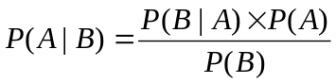
The Bayesian network is a probabilistic model that represents a set of random variables and their conditional dependencies via a direct acyclic graph (DAG). For example, a Bayesian network could represent the probabilistic relationships between activities and sensor readings. Given a set of sensor readings, the Bayesian network can be used to evaluate the probabilities that various activities are being performed.

Bayesian networks have a number of advantages. Since a Bayes network only relates nodes that are probabilistically related by a causal dependency, an enormous saving of computation can result. Therefore, there is no need to store all possible configurations of states. Instead, all that needs to be stored is the combinations of states between sets of related parent-child nodes. Also, Bayes networks are extremely adaptable. They can be started off small, with limited knowledge about the domain, and grow as they acquire new knowledge.

Bayes networks have been applied to a variety of sensor fusion problems, where data from various sources must be integrated in order to build a complete picture of the current situation. They have also been used in monitoring and alerting applications where the application should recognize whether specific events have occurred and decide if an alert or a notification should be sent. Further, they have been applied to a number of activity recognition applications and evaluated using numerous single and multiple-resident home deployments.

Bayesian networks can be divided into two groups, static and dynamic, based on whether they are able to model temporal aspects of the events / activities of interest. We introduce an example classifier for each of these two classes: static naïve Bayes classifier and dynamic naïve Bayes classifier.

Static Bayesian network classifiers
A very commonly used representative of the static Bayesian networks is the static naïve Bayes classifier. Learning Bayesian classifiers can be significantly simplified by making the naïve assumption that the features describing a class are independent. The classifier makes the assumption that the presence or absence of a feature of a class is unrelated to the presence or absence of any of the other features in the feature vector. The naïve Bayes classifier is one of the most practical learning methods and it has been widely used in many sensor network applications, including activity recognition in residence for elders (van Kasteren and Krӧse, Bayesian activity recognition in residence for elders 2007), activity recognition in the PlaceLab project at MIT (Logan, et al. 2007), outlier detection (Janakiram, AdiMallikarjuna Reddy and Phani Kumar 2006), and body sensor networks (Maurer, et al. 2006).
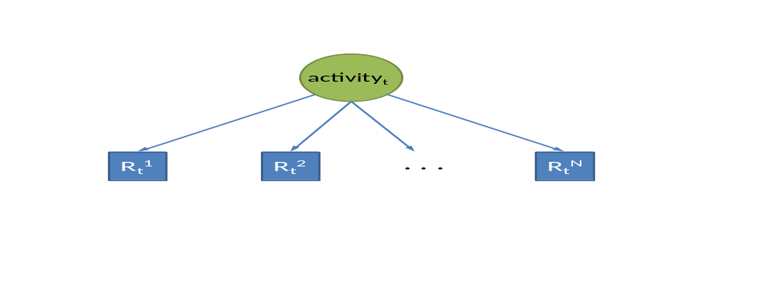
Figure 6: Static Bayesian network: activity_{t} denotes the activity being detected at time t, and R_{t}^{i} represents the data from sensor i at time t.

Figure 6 shows a naïve Bayesian model for the recognition of an activity. In this scenario the activity at time t, activity_{t}, is independent of any previous activities. It is also assumed that the sensor data R_{t} is only dependent on the activity^{t}.

Naïve Bayes classifiers have a number of advantages:
- They can be trained very efficiently.
- They are very well suited for categorical features.
- In spite of their naïve design and the independence assumptions, naïve Bayes classifiers have performed very well in many complex real-world situations. They can work with more than 1000 features.
- They are good for combining multiple models and can be used in an iterative way.

A disadvantage of naïve Bayes classifiers is that, if conditional independence is not true, i.e. there is dependence between the features of the analyzed classes, they may not be a good model. Also naïve Bayes classifiers assume that all attributes that influence a classification decision are observable and represented. Despite these drawbacks, experiments have demonstrated that naïve Bayes classifiers are very accurate classifiers in a number of problem domains. Simple naïve Bayes networks have even been proved comparable to more complex algorithms, such as decision trees (E. Tapia 2004).

Dynamic Bayesian network classifiers
Another disadvantage of static Bayesian networks is that they cannot model the temporal aspect of sensor network events. Dynamic Bayesian networks, however, are capable of representing a sequence of variables, where the sequence can be consecutive readings from a sensor node. Therefore, dynamic Bayesian networks, although more complex, might be better suited for modeling events and activities in sensor network applications.

Figure 7 shows a naïve dynamic Bayesian model, where the activity_{t+1} variable is directly influenced only by the previous variable, activity_{t}. The assumption with these models is that an event can cause another event in the future, but not vise-versa. Therefore, directed arcs between events/activities should flow forward in time and cycles are not allowed.
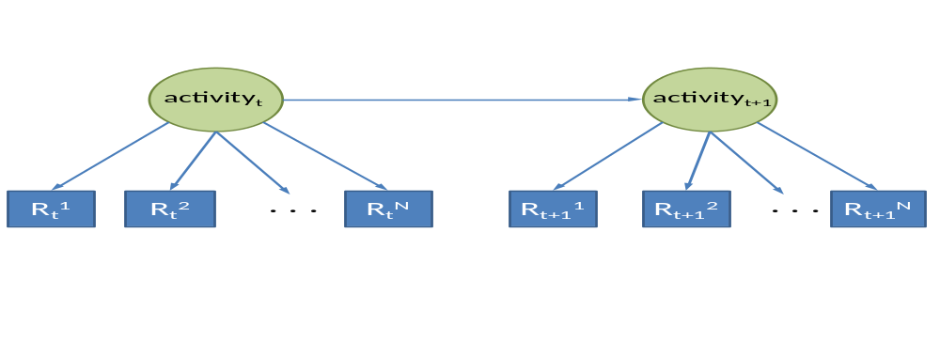
Figure 7: An example of a naïve dynamic Bayesian network.

Dynamic models have been used in activity recognition applications. A naïve dynamic Bayes classifier is compared to a naïve static Bayes classifier using two publicly available datasets (van Kasteren and Krӧse, Bayesian activity recognition in residence for elders 2007). The dynamic Bayes classifier is shown to achieve higher activity recognition accuracy than the static model. A dynamic Bayesian filter was successfully applied to the simultaneous tracking and activity recognition (STAR) problem, which exploits the synergy between location and activity to provide the information necessary for automatic health monitoring (Wilson and Atkenson 2005).

Markov models
A process is considered to be Markov if it exhibits the Markov property, which is the lack of memory, i.e. the conditional probability distribution of future states of the process depends only on the present state, and not on the events that preceded it. We discuss two types of Markov models: hidden Markov model and hidden semi-Markov model.

Hidden Markov model
A hidden Markov model (HMM) can be viewed as a simple dynamic Bayesian network. When using an HMM, the system is assumed to be a Markov process with unobserved (hidden) states. Even though the sequence of states is hidden, the output which is dependent on the state is visible. Therefore, at each time step there is a hidden variable and an observable output variable. In sensor network applications the hidden variable could be the event or activity performed, and the observable output variable is the vector of sensor readings.
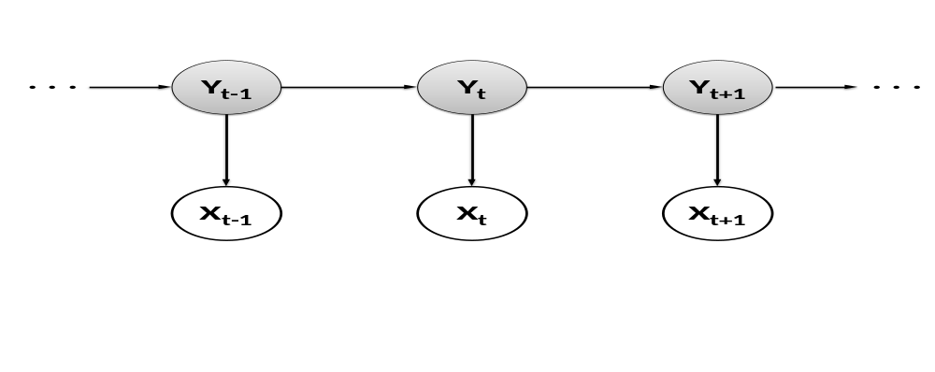
Figure 8: Hidden Markov model example. The states of the system Y_{i} are hidden, but their corresponding outputs X_{i} are visible.

Figure 8 shows an example HMM where the states of the system Y are hidden, but the output variables X are visible. There are two dependency assumptions that define this model, represented by the directed arrows in the figure:
- Markov assumption: The hidden variable at time t, namely Y_{t}, depends only on the previous hidden variable Y_{t-1}, (Rabiner 1989);
- The observable output variable at time t, namely X_{t}, depends only on the hidden variable Y_{t}.

With these assumptions we can specify an HMM using three probability distributions:
- Initial state distribution: the distribution over initial states p(Y₁);
- Transition distribution: the distribution p(Y_{t} | Y_{t+1}), which represents the probability of going from one state to the next;
- Observation distribution: the distribution p(X_{t} | Y_{t}), which indicates the probability that the hidden state Y_{t} would generate observation X_{t}.
Learning the parameters of these distributions corresponds to maximizing the joint probability distribution p(X, Y) of the paired observation and label sequences in the training data. Modeling the joint probability distribution p(X, Y) makes HMMs a generative model.

HMMs have been extensively used in many sensor network applications. Most of the earlier work on activity recognition used HMMs to recognize the activities from sensor data (Wilson and Atkenson 2005) (Patterson, et al. 2005) (van Kasteren, Noulas, et al. 2008). An HMM is also used in the smart thermostat project (Lu, et al. 2010). The smart thermostat technology automatically senses the occupancy and sleep patterns in a home, and uses these patterns to automatically operate the heating, ventilation, and cooling (HVAC) system in the home. The authors employ an HMM to estimate the probability of the home being in each of three states: unoccupied, occupied and the residents are active, and occupied with the residents sleeping. HMMs were also applied in a biometric identification application for multi-resident homes (Srinivasan, Stankovic and Whitehouse, Using Height Sensors for Biometric Identification in Multi-resident Homes 2010). In this project height sensors were mounted above the doorways in a home and an HMM was used to identify the location of each of the residents.

A weakness of conventional HMMs is their lack of flexibility in modeling state durations. With HMMs, there is a constant probability of changing state, given that the system is in its current state of the model. This, however, limits the modeling capability. For example, the activity preparing dinner typically spans at least several minutes. To prepare dinner in less than a couple of minutes is not very usual. The geometric distribution used by HMMs to represent time duration cannot be used to represent event distributions where shorter durations are less possible.

Hidden semi-Markov models
A hidden semi-Markov model (HSMM) differs from a hidden Markov model in that HSMMs explicitly model the duration of hidden states. This means that the probability of there being a change in the hidden state depends on the amount of time that has elapsed since entry into the current state.
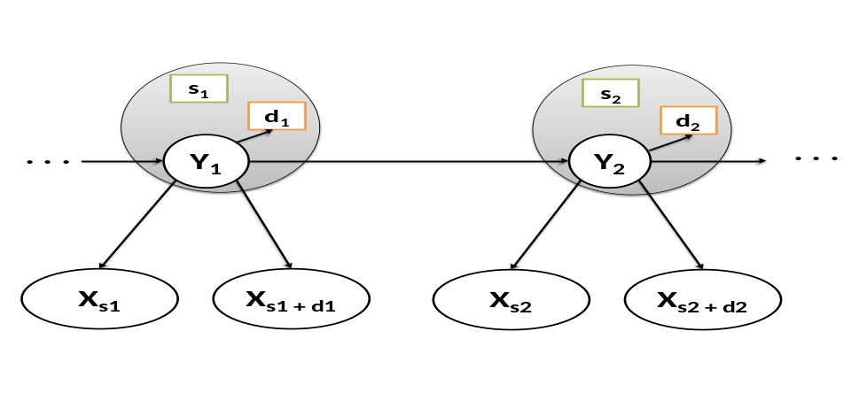
Figure 9: Hidden semi-Markov model. Each hidden state y_{i} is characterized by start position s_{i} and a duration d_{i}. This means that the system is in state y_{i} from time s_{i} to time s_{i} + d_{i}.
A number of projects have used HSMMs to learn and recognize human activities of daily living (Duong, et al. 2009) (Zhang, et al. 2008) (van Kasteren, Englebienne and Krӧse, Activity recognition using semi-Markov models on real world smart home datasets. 2010). HSMMs were also applied to behavior understanding from video streams in a nursing center (Chung and Liu 2008). The proposed approach infers elderly behaviors through three contexts: spatial, activities, and temporal. HSMM were also used in a mobility tracking application for cellular networks (Mark and Zaidi 2002).

The activity recognition accuracy achieved by HSMM is compared to that of HMM (van Kasteren, Englebienne and Krӧse, Activity recognition using semi-Markov models on real world smart home datasets. 2010). The authors evaluate the recognition performance of these models using two fully annotated real world datasets consisting of several weeks of data. The first dataset was collected in a 3-room single-resident apartment and the second dataset was from a 6-room single-resident house. The results show that HSMM consistently outperforms HMM. This indicates that accurate duration modelling is important in real world activity recognition applications as it can lead to significantly better performance. The use of duration in the classification process helps especially in scenarios where the sensor data does not provide sufficient information to distinguish between activities.

Conditional random fields
Conditional random fields (CRF) are often considered an alternative to hidden Markov models. The CRF is a statistical modeling method, which is a type of an undirected probabilistic graphical model that defines a single log-linear distribution over label sequences given a particular observation sequence. It is used to encode known relationships between observations and construct consistent interpretations.
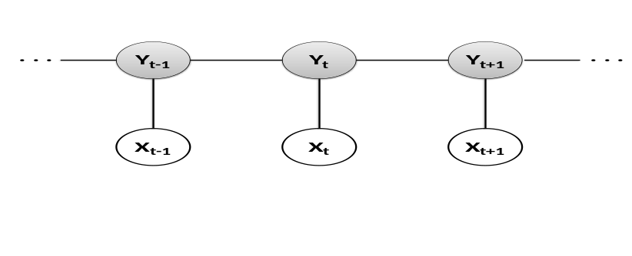
Figure 10: A linear-chain conditional random field (CRF) model. Similarly to an HMM, the states of the system Y_{i} are hidden, but their corresponding outputs X_{i} are visible. Unlike the HMM model, however, the graph represented by the CRF model is undirected.

The CRF model that most closely resembles an HMM is the linear-chain CRF. As figure 10 shows, the model of a linear-chain CRF is very similar to that of an HMM (Figure 8). The model still contains hidden variables and corresponding observable variables at each time step. However, unlike the HMM, the CRF model is undirected. This means that two connected nodes no longer represent a conditional distribution. Instead we can talk about potential between two connected nodes. In comparison to HMM, the two conditional probabilities, observation probability p(X_{t} | Y_{t}) and transition probability p(Y_{t} | Y_{t+1}), have been replaces by the corresponding potentials. The essential difference lies in the way we learn the model parameters. In the case of HMMs the parameters are learned by maximizing the joint probability distribution p(X, Y). CRFs are discriminative models. The parameters of a CRF are learned by maximizing the conditional probability distribution p(Y | X), which belongs to the family of exponential distributions (Sutton and McCailum 2006).

CRF models have been applied to activity recognition in home from video streams, in which primitive actions, such as ‘go-from-A- to-B’ are recognized in a lab-like dining room and kitchen setup (Truyen, Bui and Venkatesh, Human Activity Learning and Segmentation using Partially Hidden Discriminative Models 2005). The results from these experiments show that CRFs perform significantly better than the equivalent generative HMMs even when a large portion of the data labels are missing. CRFs were also used for modeling concurrent and interleaving activities (Hu, et al. 2008). The authors perform experiments using one of the MIT PlaceLab datasets (Logan, et al. 2007), PLA1, which consists of four hours of sensor data.

T. van Kasteren et al. use four different datasets, two bathroom datasets and two kitchen datasets, to compare the performance of HMM to that of CRF (van Kasteren, Englebienne and Krӧse, Activity recognition using semi-Markov models on real world smart home datasets. 2010). The experiments show that, when applied to activity recognition tasks, CRF models achieve higher accuracy than HMM models. The authors contribute the results to the flexibility of discriminative models, such as CRF, in dealing with violations of the modeling assumptions. However, the higher accuracy achieved by CRF models comes at a price:
- Discriminative models take much longer to train than their generative counterpart.
- Discriminative models are more prone to overfitting. Overfitting occurs when a model describes random noise instead of the underlying relationship. This happens when the model is trained to maximize its performance on the training data. However, a model’s efficiency is determined not by how well it performs on the training data but by its generality and how it performs on unseen data.
Whether the improved recognition performance of CRFs is worth the extra computational cost depends on the application. The data can be modeled mode accurately using an HSMM, which allows both speedy learning and good performance, and is less prone to overfitting. However, it does result in slower inference and depends on correct modeling assumptions for the durations.

Semi-Markov conditional random fields
Similarly to HMMs, which have their semi-Markov variant, conditional random fields also have a semi-Markov variant: semi-Markov conditional random fields (SMCRF). An example SMCRF model is shown in Figure 11. The SMCRF inherits features from both semi-Markov models and CRFs:
- It models the duration of states explicitly (like HSMM).
- Each of the hidden states is characterized by a start position and duration (like HSMM).
- The graph of the model is undirected (like CRF).

Hierarchical SMCRF were used in an activity recognition application on a small laboratory dataset from the domain of video surveillance (Truyen, Phung, et al. 2008). The task was to recognize indoor trajectories and activities of a person from his noisy positions extracted from the video. The data had 90 sequences, each of which corresponded to one of three possible activities: preparing a short meal, preparing a normal meal, and having a snack. The hierarchical SMCRF outperformed both a conventional CRF and a dynamic CRF.
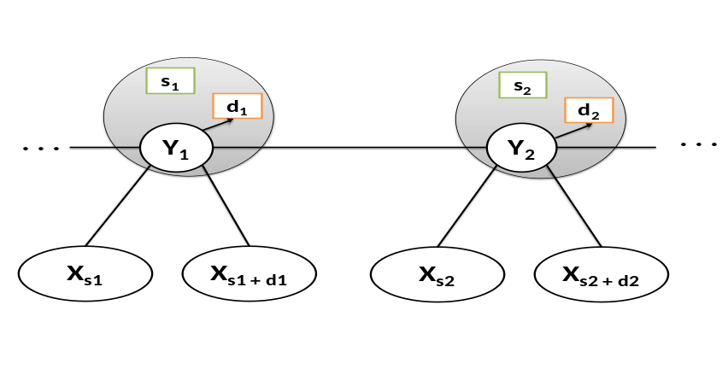
Figure 11: An example semi-Markov conditional random field (CRF). Similarly to an HSMM model, each of the hidden states y_{i} is characterized by start position s_{i} and a duration d_{i}. However, unlike an HSMM, the HMCRF graph is undirected.

SMCRFs were also used for activity recognition by van Kasteren et al. (van Kasteren, Englebienne and Krӧse, Activity recognition using semi-Markov models on real world smart home datasets. 2010). The results show that unlike the big improvement achieved by using HSMMs over HMMs, SMCRFs only slightly outperform CRFs. The authors attribute this result to the fact that CRFs are more robust in dealing with violations to the modeling assumptions. Therefore, allowing to explicitly model duration distributions might not have the same significant benefits as seen with HSMM.

Support vector machines
A support vector machine (SVM) is a non-probabilistic binary linear classifier. The output prediction of an SVM is one of two possible classes. Given a set of training instances, each marked as belonging to one of two classes, an SVM algorithm builds an N-dimensional hyperplane model that assigns future instances into one of the two possible output classes.
As shown in Figure 12, an SVM model is a representation of the input instances as points in space, mapped so that the instances of the separate classes are divided by a clear gap. New examples are then mapped into that same space and predicted to belong to a class based on which side of the gap they fall on. In other words, the goal of the SVM analysis is to find a line that separates the instances based on their class. There are an infinite number of possible lines and one of the challenges with SVM models is finding the optimal line.
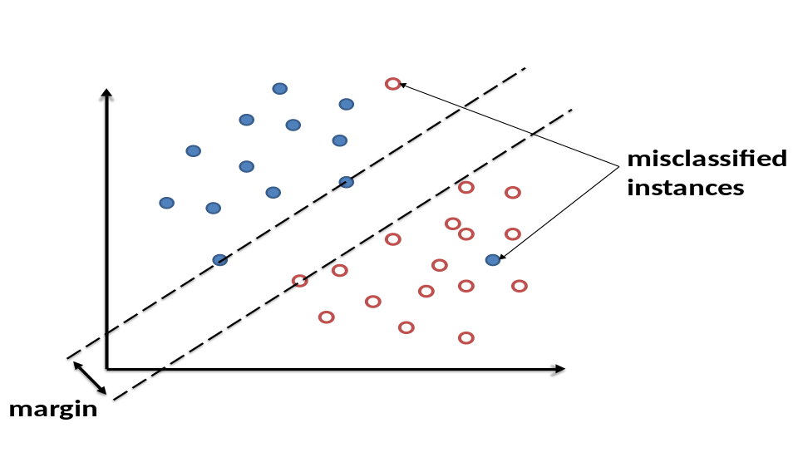
Figure 12: A two-dimensional support vector machine (SVM) model. The instances of the two possible classes are divided by a clear gap.

SVMs have been applied to a large number of sensor network applications. Sathik et al. use SVMs in an early forest fire detection applications (Mohamed Sathik, Syed Mohamed and Balasubramanian 2010). SVMs were also applied to target classification applications for distributed sensor networks (Li, et al. 2001). The experiments were performed on real seismic and acoustic data. SVMs are compared to a k-nearest neighbor algorithm and a maximum likelihood algorithm and are shown to achieve the highest target classification accuracy. Tran et al. use SVMs to achieve accurate geographic location estimations for nodes in a WSN, where the majority of nodes do not have effective self-positioning functionality (Tran and Nguyen 2008). SVMs were also applied to investigating the possibility of recognizing visual memory recall (Bulling and Roggen 2011). The project aims to find if people react differently to images they have already seen as opposed to images they are seeing for the first time.

K-nearest neighbor algorithms
The k-nearest neighbor (k-NN) algorithm is among the simplest of machine learning algorithms, yet it has proven to be very accurate in a number of scenarios. The training examples are vectors in a multidimensional feature space, each with a class label. The training phase of the algorithm consists only of storing the feature vectors and class labels of the training samples. A new instance is classified by a majority vote of its neighbors, with the instance being assigned the class that is most common among its k nearest neighbors.
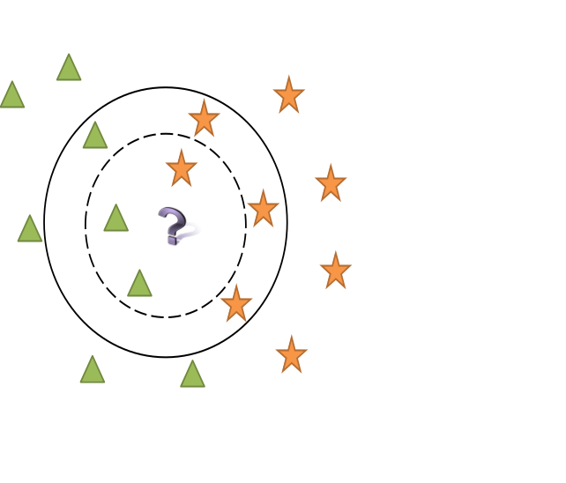
Figure 13: Example of k-nearest algorithm classification. The question mark is the test sample and it should be classified as either a star or a triangle. If k = 3, the test sample is assigned to the class of triangles because there are 2 triangles and 1 star inside the inner circle. If k = 7, the test sample is assigned to the class of stars since there are 4 stars and 3 triangles in the outer circle.
The best choice of k depends upon the data. k must be a positive integer and it is typically small. If k = 1, the new instance is simply assigned to the class of its nearest neighbor. Larger values of k reduce the effect of noise on the classification but make boundaries between classes less distinct. A good k can be selected by various heuristic techniques, for example cross-validation.

Although the k-NN algorithm is quite accurate, the time required to classify an instance could be high since the algorithm has to compute the distances (or similarity) of that instance to all the instances in the training set. Therefore, the classification time of k-NN is proportional to the number of features and the number of training instances.

k-NN algorithms have been applied to a wide variety of sensor network applications. Ganesan et al. propose the use of k-NN for spatial data interpolation in sensor networks (Ganesan, et al. 2004). Due to its simplicity, k-NN allows the sampling to be done in a distributed and inexpensive manner. A disadvantage with this approach, however, is that k-NN interpolation techniques might perform poorly in highly irregular settings. Winter et al. also analyze the application of k-NN queries for spatial data queries in sensor networks (Winter, Xu and Lee 2005). They design two algorithms based on k-NN, which are used to intelligently prune off irrelevant nodes during query propagation, thus reducing the energy consumption while maintaining high query accuracy. Duarte et al. evaluate the accuracy of k-NN in the context of vehicle classification (Duarte and Hu 2004). The authors collect a real-world dataset and analyze both the acoustic and the seismic modality. The results show that in this application scenario k-NN algorithms achieve comparable accuracy to that of SVMs.

Unsupervised Learning
Collecting labeled data is resource and time consuming and accurate labeling is often hard to achieve. For example, obtaining sufficient training data for activity recognition in a home might require three or four weeks of collecting and labeling data. Further, labeling is difficult not only for remote areas which are not easily accessible, but also for home and commercial building deployments. For any of those deployments someone has to perform the data labeling. In a home deployment, the labeling can be done by the residents themselves, in which case they have to keep a log of what they are doing and at what time. Previous experience has shown that these logs are often incomplete and inaccurate. An alternative solution is to install cameras throughout the house and monitor the activities of the residents. However, this approach is considered to be privacy-invasive and therefore not suitable.

In unsupervised learning the learner is provided with input data, which has not been labeled. The aim of the learner is to find the inherent patterns in the data that can be used to determine the correct output value for new data instances. The assumption here is that there is a structure to the input space, such that certain patterns occur more often than others, and we want to see what generally happens and what does not. In statistics, this is called density estimation.

Unsupervised learning algorithms are very useful for sensor network applications for a number of reasons:
- Collecting labeled data is resource and time consuming;
- Accurate labeling is hard to achieve;
- Sensor networks applications are often deployed in unpredictable and constantly changing environments. Therefore, the applications need to evolve and learn without any guidance, by using unlabeled patterns.
A variety of unsupervised learning algorithms have been used in sensor network applications, including different clustering algorithms, such as k-means and mixture models; self-organizing maps (SOM); and adaptive resonance theory (ART). In the rest of this section we describe some of the most commonly used unsupervised learning algorithms.

Clustering
Clustering, also called cluster analysis, is one form of unsupervised learning. It is often employed in pattern recognition tasks and activity detection applications. A clustering algorithm partitions the input instances into a fixed number of subsets, called clusters, so that the instances in the same cluster are similar to one another with respect to some set of metrics.
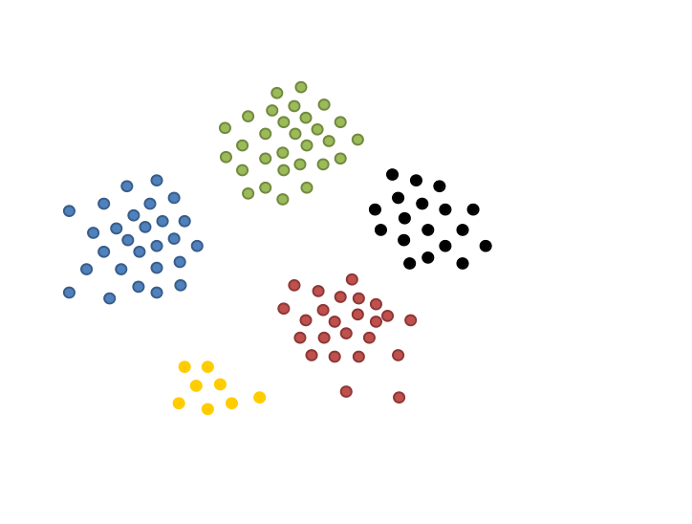
Figure 14: A clustering algorithm divides the set of input data instances into groups, called clusters. The instances in the same group are more similar to each other than to those in other clusters.

Cluster analysis itself is not one specific algorithm, but the general task to be solved. The clustering can be achieved by a number of algorithms, which differ significantly in their notion of what constitutes a cluster and how to efficiently find them. The choice of an appropriate clustering algorithms and parameter settings, including values, such as the distance function to use, a density threshold, or the number of expected clusters, depends on the individual dataset and intended use of the results.

The notion of a cluster varies between algorithms and the clusters found by different algorithms vary significantly in their properties. Typical cluster models include:
- Connectivity models: An example of a connectivity model algorithm is hierarchical clustering which builds models based on distance connectivity.
- Centroid models: A representative of this set of algorithms is the k-means algorithm. With this algorithm each cluster is represented by a single mean vector.
- Distribution models: clusters are modeled using statistics distributions.
- Density models: an example of density model clustering is DBSCAN. In this type of clustering, clusters are identified as areas with higher density than non-clusters.
- Group models: These clustering algorithms are not able to provide a refined model for the results. Instead, they can only generate the group information.
We discuss in more detail two of the most common clustering algorithms used in sensor network applications: k-means clustering, and DBSCAN clustering.

K-means clustering
The goal of k-means clustering is to partition the input instances into k clusters, where each instance belongs to the cluster with the nearest mean. Since the problem is NP-hard, the common approach is to only search for approximate solutions. There are a number of efficient heuristic algorithms that can quickly converge to a local optimum, such as the Lloyd’s algorithm (Lioyd 1982). Since the algorithms only find local optimums, they are usually run multiple times with different random initializations.

An advantage of the k-means algorithm is that it is simple and converges quickly when the number of dimensions of the data is small. However, k-means clustering also has a number of drawbacks. First, k must be specified in advance. Also, the algorithms prefer clusters of approximately similar sizes. This often leads to incorrectly cut borders in between clusters, which is not surprising since, being centroid a model algorithm, k-means optimizes for cluster center rather than cluster borders.

Figure 15 shows a clustering example where k=2 and k-means is not able to accurately define the borders between the two clusters. There are two density clusters in that figure. One of them is much larger and contains circles. The other one is smaller and consists of triangles. Since k-means optimizes for cluster center and tends to produce clusters with similar sizes, it incorrectly splits the data instances into a green and a red cluster. These two clusters, however, do not overlap with the original density clusters of the input data.
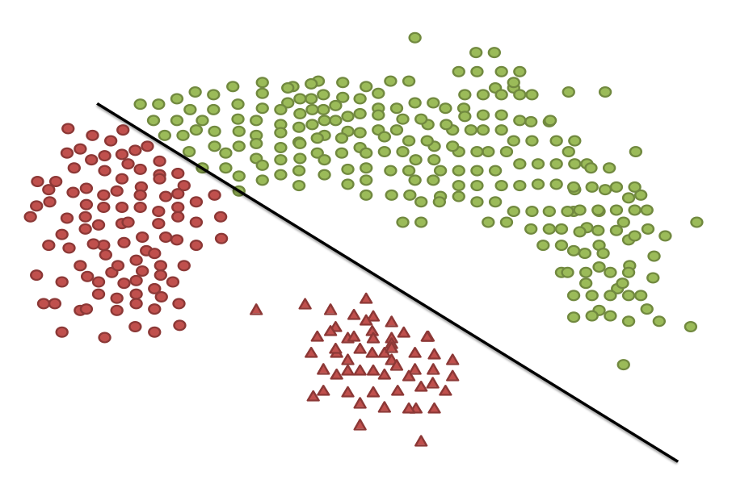
Figure 15: K-means clustering might incorrectly cut the bothers between density-based clusters.

K-means clustering has been used in a number of WSN applications. A k-means algorithm is used in the fingerprint and timing-based snooping (FATS) security attack to cluster together sensors that are temporally correlated (Srinivasan, Stankovic and Whitehouse, Protecting your Daily In-Home Activity Information from a Wireless Snooping Attack 2008). This allows the attack to identify sensors that fire together, and hence identify sensors that are located in the same room. K-means clustering has also been used to address the multiple sink location problem in large-scale WSNs (Oyman and Ersoy 2004). In large scale-networks with a large number of sensor nodes, multiple sink nodes should be deployed not only to increase the manageability of the network but also to prolong the lifetime of the network by reducing the energy dissipation of each node. Al-Karaki et al. apply k-means clustering to data aggregation, and more specifically to finding the minimum number of aggregation points in order to maximize the network lifetime (Al-Karaki, Ul-Mustafa and Kamal 2004). The results from their experiments show that, compared to a number of other algorithms, such as a genetic algorithm and a simple greedy algorithm, k-means clustering achieves the highest network lifetime extension.

DBSCAN clustering
The density-based spatial clustering for applications with noise (DBSCAN) is the most popular density-based clustering algorithm. In density-based clustering, clusters are defined as areas of higher density than the remainder of the dataset. DBSCAN requires two parameters: distance threshold (Eps-neighborhood of a point) and minimum number of points required to form a cluster (MinPts) (Ester, et al. 1996). DBSCAN is based on connecting points within a certain distance of each other, i.e. points which are in the same Eps-neighborhood. However, in order to make a cluster, DBSCAN requires that for each point in the cluster there are at least MinPts number of points in the Eps-neighborhood. Figure 16 shows an example of DBSCAN clustering. The dataset is the same as that in Figure 15 but since a density-based clustering algorithm has been used, the data is clustered correctly.
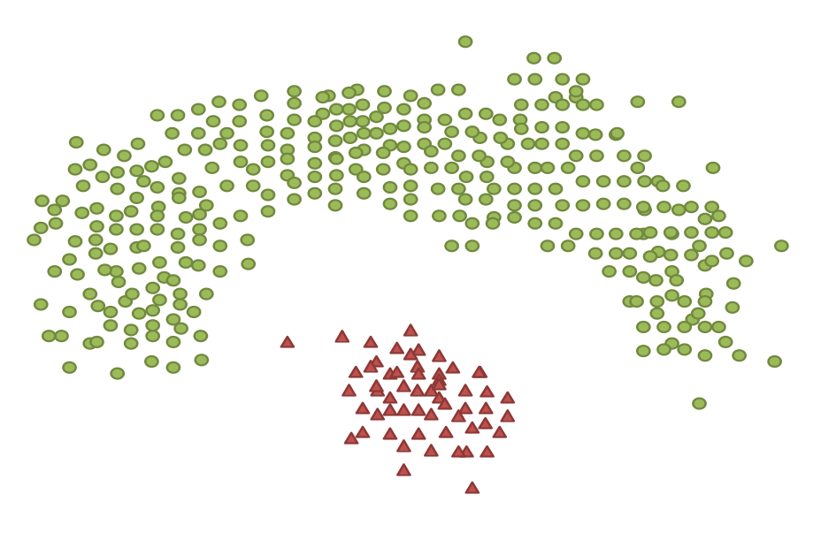
Figure 16: An example density-based clustering with DBSCAN.
An advantage of DBSCAN is that, unlike many other clustering algorithms, it can form clusters of any arbitrary shape. Another useful property of the algorithm is that its complexity is fairly low and it will discover essentially the same clusters in each run. Therefore, in contrast to k-means clustering, DBSCAN can be run only once rather than multiple times. The main drawback of DBSCAN is that it expects sufficiently significant density drop in order to detect cluster borders. If the cluster densities decrease continuously, DBSCAN might often produce clusters whose borders look arbitrary.

In sensor network applications, DBSCAN has been used as part of the FATS security attack to identify the function of each room, such as bathroom, kitchen, or bedroom (Srinivasan, Stankovic and Whitehouse, Protecting your Daily In-Home Activity Information from a Wireless Snooping Attack 2008). DBSCAN generates temporal activity clusters, each of which forms a continuous temporal block with a relatively high density of sensor firings. Experiments show that DBSCAN performs very well because it automatically leaves out outliers and computes high-density clusters. However, when DBSCAN is applied to the step of identifying which sensors are in the same room, k-means clustering performs much better. This is especially true for scenarios where all devices are highly correlated temporally and there is no significant density drop on the boundary of clusters.

Apiletti et al. also apply DBSCAN to detecting sensor correlation (Apiletti, Baralis and Carquitelli 2011). The authors perform experiments using data collected from a sensor network deployed in university labs. The results show that DBSCAN is able to identify different numbers of clusters based on which day of the week it is analyzing. This allows it to construct more accurate models for the sensor use parrerns in the labs. DBSCAN also successfully detects noisy sensors.

Self-organizing map (SOM)
Self-organizing maps (SOM) provide a way of representing multidimensional data in much lower dimensional spaces – typically one or two dimensions. The process of reducing the dimensionality of the feature vectors is a data compression technique known as vector quantisation. SOMs, as indicated by their name, produce a representation of the compressed feature space, called a map. An extremely valuable property of these maps is that the information is stored in such a way that any topological relationships within the training set are maintained.

An SOM contains components called nodes. Each node is associated with 1) a position in the map space and 2) a vector of weights, where the dimension of this vector is the same as that of the input data instances. The nodes are regularly spaced in the map, which is typically a rectangular or a hexagonal grid. A typical example of SOMs is a color map (Figure 17). Each color is represented by a 3-dimensional vector containing values for red, green, and blue. However, the color SOM represents the colors in a 2-dimensional space.

Figure 17: An example SOM representation for colors.
The procedure of placing an input data instance onto the map is the following:
- Initialize the weights of the nodes on the map.
- Choose an input training instance.
- Find the node with the closest vector to that of the input instance. This node is called the best matching unit (BMU).
- Calculate the radius of the BMU’s neighborhood. This value is often set to the radius of the whole map, but it decreases at each time step. Any node found within this radius is considered to be inside the BMU’s neighborhood.
- Once the BMU is located, it is assigned the values from the vector of the input instance. In addition, the weights of the nodes close to the BMU are also adjusted towards the input vector. The closer a neighbor node is to the BMU, the more its weight is altered.

In sensor networks, SOMs have been applied to anomaly detection caused by faulty sensors and unusual phenomenon, such as harsh environmental conditions (Siripanadorn, Hattagam and Teaumroong 2010). Paladina et al. have also used SOMs for node localization (Paladina, et al. 2007). Their localization technique is based on a simple SOM implemented on each of the sensor nodes. The main advantages of this approach are the limited storage and computing cost. However, the processing time required by the SOMs increases with the size of the input data. Giorgetti et al. have also applied SOMs to addressing node localization (Giorgetti, Gupta and Manes 2007). Their SOM-based algorithm computes virtual coordinates that are used in location-aided routing. If the location information for a few anchor nodes is available, the algorithm is also able to compute the absolute positions of the nodes. The results from the experiments further show that the SOM-based algorithm performs especially well for networks with low connectivity, which tend to be harder to localize, and in the presence of irregular radio patterns or anisotropic deployment. A variation of an SOM, called a growing self-organized map (GSOM) is employed to achieve accurate detection of human activities of daily living within smart home environments (Zheng, Wang and Black 2008).

Adaptive resonance theory (ART)
Most existing learning algorithms are either stable (they preserve previously learned information) or plastic (they retain the potential to adapt to new input instances indefinitely). Typically, algorithms that are stable cannot easily learn new information, and algorithms that are plastic tend to forget the old information they have learned. This conflict between stability and plasticity is called the stability-plasticity dilemma (Carpenter and Grossberg 1987).

The adaptive resonance theory (ART) architectures attempt to provide a solution to the stability-plasticity dilemma. ART is a family of different neural architectures that address the issue of how a learning system can preserve its previously learned knowledge while keeping its ability to learn new patterns. An ART model is capable of distinguishing between familiar and unfamiliar events, as well as between expected and unexpected events.

An ART system contains two functionally complementary subsystems that allow it to process familiar and unfamiliar events: attentional subsystem and orienting subsystem. Familiar events are processed within the attentional subsystem. This goal of this subsystem is to constantly establish even more precise internal representations of and responses to familiar events. By itself, however, the attentional subsystem is unable to simultaneously maintain stable representations of familiar categories and to create new categories for unfamiliar events. This is where the orienting subsystem helps. It is used to reset the attentional subsystem when an unfamiliar event occurs. The orienting subsystem is essential for expressing whether a novel pattern is familiar and well represented by an existing recognition code, or unfamiliar and in need of a new recognition code.
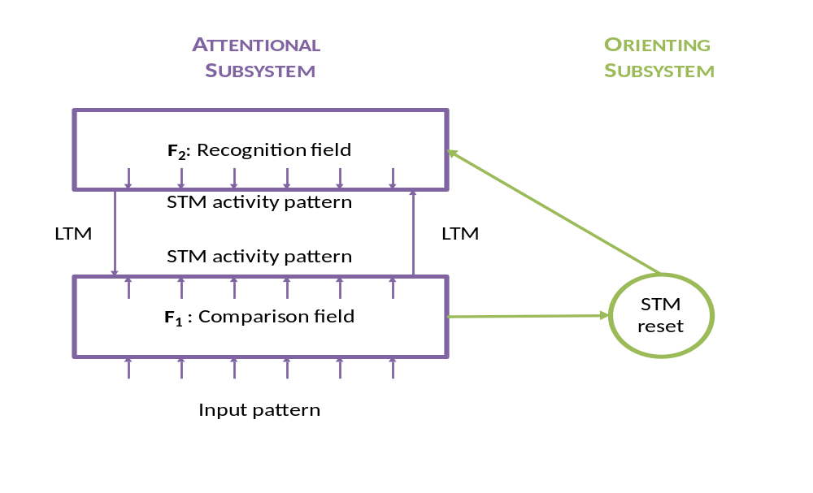
Figure 18: The architecture of an ART system has two subsystems: attentional, responsible for processing familiar events, and orienting, which helps reset the attentional subsystem when an unfamiliar event occurs. The attentional subsystem contains a comparison field, where the input is received, and a recognition field, which assigns the input to a category. Both short term memory (STM) and long term memory (LTM) are employed.

Figure 18 shows the architecture of an ART system. The attentional system has two successive stages, F₁ and F₂, which encode patterns of activation in short term memory (STM). The input pattern is received at F₁, and the classification is performed at F₂. Bottom-up and top-down pathways between the two stages contain adaptive long term memory (LTM) traces. The orienting subsystem measures the similarity between the input instance vector and the pattern produced by the fields in the attentional subsystem. If the two are similar, i.e. if the attentional subsystem has been able to recognize the input instance, the orienting subsystem does not interfere. However, if the two patterns are significantly different, the orienting subsystem resets the output of the recognition layer. The effect of the reset is to force the output of the attentional system back to zero, which allows the system to search for a better match.

A drawback of some of the ART architectures is that the results of the models depend significantly on the order in which the training instances are processed. The effect can be reduced to some extent by using a slower learning rate, where differential equations are used and the degree of training on an input depends on the time the input is available. However, even with slow training, the order of training still affects the system regardless of the size of the input dataset.

ART classifiers have been applied to WSN applications to address anomaly detection problems in unknown environments (Li, Thomason and Parker, Detecting Time-Related Changes in Wireless Sensor Networks Using Symbol Compression and Probabilistic Suffix Trees 2010). A fuzzy ART classifier is used to label multi-dimensional sensor data into discrete classes and detect sensor-level anomalies. An ART classification is also employed by an intruder detection system that uses a WSN and mobile robots (Li and Parker, Intruder detection using a wireless sensor network with an intelligent mobile robot response 2008). The sensor network uses an unsupervised fuzzy ART classifier to learn and detect intruders in a previously unknown environment. Upon the detection of an intruder, a mobile robot travels to investigate the position where the intruder is supposed to be. Kulakov et al. incorporate ART into a technique used for detection of unusual sensor events and sensor failures (Kulakov and Davcev 2005). Through simulation, where one of the input sensor nodes is failed on purpose, the authors show the improvement in data robustness achieved by their approach.

Other unsupervised machine learning algorithms
There is a wide variety of unsupervised learning algorithms, in addition to k-means clustering, DBSCAN, SOM, and ART, which have been often applied to WSN application. The SmartHouse project uses a system of sensors to monitor a person’s activities at home (Barger, Brown and Alwan 2005). The goal of the project is to recognize and detect different behavioral patterns. The authors use mixture models to develop a probabilistic model of the behavioral patterns. The mixture model approach serves to cluster the observations with each cluster considered to be a different event type.

A number of activity recognition projects have developed unsupervised learning algorithms that extract models from text corpora or the web. The Guide project uses unsupervised learning methods to detect activities using RFID tags placed on objects (Philipose, et al. 2003). This method relies on data mining techniques to extract activity models from the web in an unsupervised fashion. For this project the authors have mined the temporal structure of about fifteen thousand home activities.

Gu et al. develop another unsupervised approach based on RFID-tagged object-use fingerprints to recognize activities without human labeling (Gu, et al. 2010). The activity models they use are built based on object-use fingerprints, which are sets of contrast patterns describing significant differences in object-use between any two activity classes. This is done by first mining a set of object terms for each activity class from the web, and then mining contrast patterns among object terms based on emerging patterns to distinguish between any two activity patterns.

Wyat et al. also employ generic mined models from the web (Wyatt, Philipose and Choudhury 2005). Given an unlabeled trace of object names from a user performing their activities of daily living, they use the generic mined models to segment the trace into labeled instances of activities. After that they use the labeled instances to learn custom models of the activity from the data. For example, they learn details such as order of object use, duration of use, and whether additional object are used.

Tapia et al. develop a similar approach where they extract relevant information on the functional similarity of objects automatically from WordNet, which is an online lexical reference system for the English language (Tapia, Choudhury and Philipose 2006). The information about the functional similarity between objects is represented in a hierarchical form known as ontology. This ontology is used to help mitigate the problem of model incompleteness, which often affects the techniques used to construct activity recognition models.

An unsupervised approach based on detecting and analyzing the sequence of objects that are being used by the residents is described in (Wu, et al. 2007). The activity recognition method is based on RFID object-use correlated with video streams, and information collected from how-to websites such as about.com. Since video streams are used, the approach provides high-grained activity recognition. For example, it can differentiate between making tea and making coffee. However, as previously mentioned, collecting video data of home activities is difficult due to privacy concerns.

Dimitrov et al. develop a system that relies on unsupervised recognition to identify activities of daily living in a smart home environment (Dimitrov, Pauli and Naroska 2010). The system utilizes background domain knowledge about the user activities, which is stored in a self-updating probabilistic knowledge base. The system aims to build the best possible explanation for the observed stream of sensor events.

Semi-Supervised Learning
Semi-supervised learning algorithms use both labeled and unlabeled data for training. The labeled data is typically a small percentage of the training dataset. The goal of semi-supervised learning is to 1) understand how combining labeled and unlabeled data may change the learning behavior, and 2) design algorithms that take advantage of such a combination. Semi-supervised learning is a very promising approach since it can use readily available unlabeled data to improve supervised learning tasks when the labeled data is scarce or expensive.

There are many different semi-supervised learning algorithms. Some of the most commonly used ones include:

- Expectation-Maximization with generative mixture models
Expectation-maximization (EM) is an iterative method for finding maximum likelihood estimates of parameters in statistical models, where the models depend on unobserved latent variables (Dempster, Laird and Rubin 1977). Each iteration of the algorithm consists of an expectation step (e-step) followed by a maximization step (m-step). EM with generative mixture models are suitable for applications where the classes specified by the application produce well clustered data.

- Self-training
Self-training can refer to a variety of schemes for using unlabeled data. Ng and Cardie implement self-training by bagging and majority voting (Ng and Cardie 2003). An ensemble of classifiers is trained on the labeled data instances and then the classifiers are used to classify the unlabeled examples independently. Only those examples, for which all classifiers assign the same label, are added to the labeled training set, and the classifier ensemble is retrained. The process continues until a stop condition is met.

A single classifier can also be self-trained. Similarly to the ensemble of classifiers, the single classifier is first trained on all labeled data. Then the classifier is applied to the unlabeled instances. Only those instances that meet a selection criterion are added to the labeled set and used for retraining.

- Co-training
Co-training requires two or more views of the data, i.e. disjoint feature sets that provide different complementary information about the instances (Blum and Mitchell, Combining Labeled and Unlabeld Data with Co-Training 1998). Ideally, the two feature sets for each instance are conditionally independent. Also each feature set should be sufficient to accurately assign each instance to its respective class. The first step in co-training is to use all labeled data and train a separate classifier for each view. Then, the most confident predictions of each classifier are used on the unlabeled data to construct additional labeled training instances. Co-training is a suitable algorithm to use if the features of the dataset naturally split into two sets.

- Transductive support vector machines
Transductive SVMs extend general SVMs in that they could also use partially labeled data for semi-supervised learning by following the principles of transduction (Gammerman, Vovk and Vapnik 1998). In inductive learning, the algorithm is trained on specific training instances but the goal is to learn general rules, which are then applied to the test cases. In contrast, transductive learning is reasoning from specific training cases to specific testing cases.

- Graph-based methods
These are algorithms that utilize the graph structure obtained by capturing pairwise similarities between the labeled and unlabeled instances (Zhu 2007). These algorithms define a graph structure where the nodes are labeled and unlabeled instances and the edges, which may be weighted, represent the similarity of the nodes they connect.

In sensor networks, semi-supervised learning has been applied to localization of mobile objects. Pan et al. develop a probabilistic semi-supervised learning approach to reduce the calibration effort and increase the tracking accuracy of their system (Pan, et al. 2007). Their method is based on semi-supervised CRFs, which effectively enhance the learned model from a small set of training data with abundant unlabeled data. To make the method more efficient, the authors employ a Generalized EM algorithm coupled with domain constraints. Yang et al. use a semi-supervised manifold learning algorithm to estimate the locations of mobile nodes in a WSN (Yang, et al. 2010). The algorithm is used to compute a subspace mapping function between the signal space and the physical space by using a small amount of labeled data and a large amount of unlabeled data.

Wang et al. develop a semi-supervised learning algorithm based on SVM (Wang, et al. 2007). The algorithm has been applied to target classification and the experimental results show that it can accurately classify targets in sensor networks.

Semi-supervised learning has also been applied to object detection and recognition of commonly displaced items. Xie et al. propose a dual-camera sensor network that can be used as memory assistant tool (Xie, et al. 2008). Their approach extracts the color features of every new object and then uses a semi-supervised clustering algorithm to classify the object. The user is provided with the option to review the results of the classification algorithm and label images that have been mislabeled, thus providing real-time feedback to the system to refine the data model of the semi-supervised clustering.

Summary
Machine learning has been steadily entering the area of sensor network applications. Since its application to routing problems in wireless networks as early as 1994 (Cowan, Tesauro and Alspector 1994), it has been used to address problems, such as activity recognition, localization, sensor fusion, monitoring and alerting, outlier detection, energy efficiency in the home, to name a few. Future work will further extend both the application domains and the set of machine learning techniques that are used.

Bibliography
Al-Karaki, Jamal N., Raza Ul-Mustafa, and Ahmed E. Kamal. "Data Aggregation in Wireless Sensor Networks - Exact and Approximate Algorithms." Workshop on High Performance Switching and Routing. 2004. 241-245.
Apiletti, Daniele, Elena Baralis, and Tania Carquitelli. "Energy-saving models for wireless sensor networks." Knowledge and Information Systems (Springer London) 28, no. 3 (2011): 615-644.
Barger, Tracy, Donald Brown, and Majid Alwan. "Health Status Monitoring Through Analysis of Behavioral Patterns." IEEE Transactions on Systems, Man, and Cybernetics, Part A: Systems and Humans 35, no. 1 (2005): 22-27.
Blum, Avrim, and Shuchi Chwala. "Learning from Labeled and Unlabeled Data using Graph Mincuts." Eighteenth International Conference on Machine Learning (ICML '01). 2001. 19-26.
Blum, Avrim, and Tom Mitchell. "Combining Labeled and Unlabeld Data with Co-Training." 11th Annual Conference on COmputational Learning Theory. 1998. 92-100.
Bulling, Andreas, and Daniel Roggen. "Recognition of visual memory recall precesses using eye movemenr analysis." Ubiquitous Computing (UbiComp '11). 2011. 455-469.
Cabena, Peter, Pablo Hadjinian, Rolf Stadler, Jaap Verhees, and Alessandro Zanasi. Discovering data mining: from concept to implementation. Prentice-Hall, Inc., 1998.
Carpenter, Gail, and Stephen Grossberg. "A Massively Parallel Architecture for a Self-Organizing Neural Pattern Recognition Machine." Journal on Computer Virion, Graphics, and Image Processing 37, no. 1 (January 1987): 54-115.
Cayirci, Erdal, Hakan Tezcan, Yasar Dogan, and Vedat Coskun. "Wireless sensor networks for underwater surveillance systems." Ad Hoc Networks 4, no. 4 (July 2006): 431-446.
Chung, Pau-Choo, and Chin-De Liu. "A daily behavior enabled hidden Markov model for human behavior understanding." Pattern Recognition 41, no. 5 (May 2008): 1589-1597.
Cowan, jack, Gerald Tesauro, and Joshua Alspector. "Packet Routing in Dynamically Changing Networks: A Reinforcement Learning Approach." Advances in Neural Information Processing Systems 6 (1994): 671-678.
Dempster, A. P., N. M. Laird, and D. B. Rubin. "Maximum Likelihood from Incomplete Data via the EM Algorithm." Journal of the Royal Statistical Society. Series B (Methodological) 39, no. 1 (1977): 1-38.
Dimitrov, Todor, Josef Pauli, and Edwin Naroska. "Unsupervised Recognition of ADLs." SETN. 2010.
Duarte, Marco, and Yu Hen Hu. "Vehicle classification in distributed sensor networks." Journal of Parallel and Distributed Computing 64, no. 7 (July 2004): 826-838.
Duong, Thi, Dinh Phung, Hung Bui, and Svetha Venkatesh. "Efficient duration and hierarchical modeling for human activity recognition." Artificial Intelligence 173, no. 7-8 (2009): 830-856.
Ester, Martin, Hans-Peter Kriegel, Jorg Sander, and Xiaowei Xu. "A Density-Based Algorithm for Discovering Clusters in Large Spatial Databases with Noise." International Conference on Knowledge Discovery in Databases and Data Mining (KDD '96). 1996. 226-231.
Gammerman, A., V. Vovk, and V. Vapnik. "Learning by Transduction." Uncertaingy in Artificial Intelligence, 1998: 148-155.
Ganesan, Deepak, Sylvia Ratnasamy, Hanbiao Wang, and Deborah Estrin. "Coping with irregular spatio-temporal samplingin sensor networks." ACM SIGCOMM Computer Communication Review, 2004: 125-130.
Giorgetti, Gianni, Sandeep K. S. Gupta, and Gianfranco Manes. "Wireless Localization Using Self-Organizing Maps." 6th International conference on Information processing in sensor networks (IPSN '07). 2007. 293-302.
Gu, Tao, Shaxun Chen, Xianping Tao, and Jian Lu. "An unsupervised approach to activity recognition and segmentation based on object-use fingerprints." Data and Knowledge Engineering (Elsevier) 69 (2010): 533-544.
Han, Jiawei. Data Mining: Concepts and Techniques. Morgan Kaufmann Publisher Inc., 2005.
Hu, Derek Hao, Sinno Jialin Pan, Vincent Wenchen Zheng, Nathan Nan Liu, and Qiang Yang. "Real world activity recognition with multiple goals." Proceedings of the 10th internationaal conference on Ubiquitous computing (UbiComp '08). 2008. 30-39.
Janakiram, D., V. AdiMallikarjuna Reddy, and A. V. U. Phani Kumar. "Outlier Detection in Wireless Sensor Networks Using Bayesian Belief Networks." First International Conference on Communication System Software and Middleware. New Delhi, 2006. 1-6.
Kulakov, Andrea, and Danco Davcev. "Tracking of unusual events in wireless sensor networks based on artificial neural-networks algorithms." International Conference on Information Technology: Coding and Computing (ITCC '05). 2005. 534-539.
Langley, P., W. Iba, and K. Thompson. "An analysis of Bayesian classifiers." Tenth National Conference on Artificial Intelligence. San Jose, CA: AAAI Press, 1992. 223-228.
Li, Dan, K. D. Wong, Yu Hen Hu, and A. M. Sayeed. "Detection, classification, and tracking of targets." IEEE Signal Processing Magazine 19 (March 2001): 17-29.
Li, Yuan Yuan, and Lynne E. Parker. "Intruder detection using a wireless sensor network with an intelligent mobile robot response." SoutheastCon. 2008. 37-42.
Li, Yuan Yuan, Michael Thomason, and Lynne E. Parker. "Detecting Time-Related Changes in Wireless Sensor Networks Using Symbol Compression and Probabilistic Suffix Trees." IEEE International Conference on Intelligent Robots and Systems (IROS '10). 2010. 2946-2951.
Lioyd, S. "Least squares quantization in PCM." IEEE Transactions on Information Theory 28, no. 2 (March 1982): 129-137.
Logan, B., J. Healey, M. Philipose, and E. M. Tapia. "A long-term evaluation of sensing modalities for activity recognition." UbiComp. Innsbruck, Austria: Springer-Verlag, 2007. 483--500.
Lu, Jiakang, et al. "The smart thermostat: using occupancy sensors to save energy in homes." 8th ACM Conference on Embedded Networked Sensor Systems (SenSys '10). 2010. 211-224.
Mark, Brian L., and Zainab R. Zaidi. "Robust mobility tracking for cellular networks." IEEE International Conference on Communications. 2002. 445-449.
Maurer, Uwe, Asim Smailagic, Daniel P. Siewiorek, and Michael Deisher. "Activity Recognition and Monitoring Using Multiple Sensors on Different Body Positions." International Workshop on Wearable and Implantable Body Sensor Networks. Washington, DC: IEEE Computer Society, 2006. 113-116.
Mohamed Sathik, M., M. Syed Mohamed, and A. Balasubramanian. "Fire Detection Using Support Vector Machine in Wireless Sensor Network and Rescue Using Pervasive Devices." International Journal on Advanced Networking and Applications 2, no. 2 (2010): 636-639.
Ng, Vincent, and Claire Cardie. "Bootstrapping Coreference Classifiers with Multiple Machine Learning Algorithms." Conference on Empirical Methods in Natural Language Processing (EMNLP '03). 2003. 113-120.
Oyman, E. Ilker, and Cem Ersoy. "Multiple Sink Network Design Problem in Large Scale Wireless Sensor Networks." IEEE International Conference on Communications. 2004. 3663-3667.
Paladina, L., M. Paone, G. Jellamo, and A. Puliafito. "Self-organizing maps for distributed localization in wireless sensor networks." IEEE Symposium on Computers and Communications. 2007. 1113-1118.
Pan, Rong, et al. "Domain-constrained semi-supervised mining of tracking models in sensor networks." 13th ACM SIGKDD international conference on Knowledge discovery and data mining (KDD '07). 2007. 1023-1027.
Patterson, Donald J., Dieter Fox, Henry Kautz, and Matthai Philipose. "Fine-Grained Activity Recognition by Aggregating Abstract Object Usage." Ninth IEEE International Symposium on Wearable Computers (ISWC '05). 2005. 44-51.
Philipose, Matthai, Kenneth Fiskin, Dieter Fox, Henry Kautz, Donald Patterson, and Mike Pwrkowitz. "Guide: Towards Understanding Daily Life via Auto-Identification and Statistical Analysis." UbiHealth Workshop at UbiComp. 2003.
Quinlan, Ross. C4.5: programs for machine learning. Morgan Kaufmann Publishers Inc, 1993.
Quinlan, Ross. "Introduction of decision trees." Machine Learning, 1986: 81-106.
Rabiner, L. R. "A tutorial on hidden Markov models and selected applications in speech recognition." Proceedings of the IEEE 77 (February 1989): 257-286.
Shang, Yi, Wheeler Ruml, Ying Zhang, and Markus P. J. Fromherz. "Localization from mere connectivity." 4th ACM international symposium on Mobile ad hoc networking \& computing (MobiHoc '03). 2003. 201-212.
Siripanadorn, S., N. Hattagam, and N. Teaumroong. "Anomaly Detection in Wireless Sensor Networks using Self-Organizing Map and Wavelets." International Journal of Communications 4, no. 3 (2010): 74-83.
Srinivasan, Vijay, John Stankovic, and Kamin Whitehouse. "Protecting your Daily In-Home Activity Information from a Wireless Snooping Attack." 10th International conference on Ubiquitous computing (UbiComp '08). 2008. 202-211.
—. "Using Height Sensors for Biometric Identification in Multi-resident Homes." 8th International Conference on Pervasive Computing (Pervasive). 2010. 337-354.
Sutton, Charles, and Andrew McCailum. "An introduction to conditional random fields for relational learning." In Introduction to statistical relational learning, by Ben Taskar Lise Getoor, 93-129. MIT Press, 2006.
Tapia, Emmanuel. "Activity Recognition in the Home Using Simple and Ubiquitous Sensors." In Pervasive Computing, 158-175. Springer Berlin / Heidelberg, 2004.
Tapia, Emmanuel Manguia, Tanzeem Choudhury, and Mitthai Philipose. "Building Reliable Activity Models Using Hierarchical Shrinkage and Mined Ontology ." Pervasive. Springer-Verlag, 2006.
Tapia, Emmanuel Munguia, et al. "Real-Time Recognition of Physical Activities and Their Intensities Using Wireless Accelerometers and a Heart Rate Monitor." 11th IEEE International Symposium on Wearable Computers (ISWC '07). 2007. 1-4.
Tran, Duc A., and Thinh Nguyen. "Localization In Wireless Sensor Networks based on Support Vector Machines." IEEE Transactions on Parallel Distributed Systems, 2008: 981-994.
Truyen, Tran The, Ding Q. Phung, Hung H. Bui, and Svetha Venkatesh. "Hierarchical Semi-Markov Conditional Random Fields for Recursive Sequential Data." Neural Information Processing Systems (NIPS '08). 2008.
Truyen, Tran The, Hung H. Bui, and Svetha Venkatesh. "Human Activity Learning and Segmentation using Partially Hidden Discriminative Models." Workshop on Human Activity Recognition and Modelling (HAREM'05). 2005. 87-95.
van Kasteren, Tim, and Ben Krӧse. "Bayesian activity recognition in residence for elders." 3rd International Conference on Intelligent Environments. 2007. 209-212.
van Kasteren, Tim, Athanasion Noulas, Gwenn Englebienne, and Ben Krӧse. "Accurate activity recognition in a home setting." 10th international conference on Ubiquitous computing (UbiComp '08). 2008. 1-9.
van Kasteren, Tim, Gwenn Englebienne, and Ben Krӧse. "Activity recognition using semi-Markov models on real world smart home datasets." Journal of Ambient Intelligence and Smart Environments 2, no. 3 (2010): 311-325.
Wang, Xue, Sheng Wang, Daowei Bi, and Liang Ding. "Hierarchical Wireless Multimedia Sensor Networks for Collaborative Hybrid Semi-Supervised Classifier Learning." Sensors 7, no. 11 (2007): 2693-2722.
Wilson, D. H., and C. Atkenson. "Simultaneous tracking and activity recognition (STAR) using many anonymous, binary sensors." Pervasive. Munich, 2005. 62-79.
Winter, Julian, Yingqi Xu, and Wang-Chien Lee. "Energy Efficient Processing of K Nearest Neighbor Queries in Location-aware Sensor Networks." The Second Annual International Conference on Mobile and Ubiquitous Systems: Networking and Services (MOBIQUITOUS '05). 2005. 281-292.
Wu, Janxin, Adebola Osuntogun, Tanzeem Choudhury, Mitthai Philipose, and James M. Rehg. "A Scalable Approach to Activity Recognition based on Object Use." IEEE 11th International Conference on Computer Vision (ICCV '07). 2007.
Wyatt, Danny, Matthai Philipose, and Tanzeem Choudhury. "Unsupervised activity recognition using automatically mined common sense." 20th national conference on Artificial intelligence - Volume 1 (AAAI '05). 2005. 21-27.
Xie, Dan, Tingxin Yan, Deepak Ganesan, and Allen Hanson. "Design and Implementation of a Dual-Camera Wireless Sensor Network for Object Retrieval." 7th international conference on Information processing in sensor networks (IPSN '07). 2008. 469-480.
Yang, Bin, Jinwu Xu, Jianhong Yang, and Min Li. "Localization algorithm in wireless sensor networks based on semi-supervised manifold learning and its application." Cluster Computing (Kluwer Academic Publishers Hingham, MA, USA) 13, no. 4 (December 2010).
Zhang, Wiedong, Feng Chen, Wenli Xu, and Youtian Du. "Learning Human Activity Containing Sparse Irrelevant Events in Long Sequence." Congress on Image and Signal Processing (CISP '08). 2008. 211-215.
Zheng, Huiru, Haiying Wang, and Norman Black. "Human Activity Detection in Smart Home Environment with Self-Adaptive Neural Networks." IEEE International Conference on Networking, Sensing, and Control (ICNSC '08). 2008. 1505-1510.
Zhu, Xiaojin. Semi-Supervised Learning Literature Survey. University of Wisconsin - Madion, Computer Science TR 1530, 2007.

