**ECE 493/593 Telehealthcare Engineering** (Final Exam, Fall 2012)

X/100

Name:

* 20% of your final grade; Closed book & notes.
* Total 2 and a half hours. Take your time.
* Calculator allowed.
* Total 100 points. No discussions.

**Q1. (5%) Explain how we use symmetric and asymmetric cryptography schemes to secure healthcare data transmissions in a network.**

**Q2. (5%) What is message digest? How do we use it to achieve digital signature?**

**Q3. (5%) Explain how we can achieve email confidentiality, authentication and integrity.**

**Q4. (5%) Explain WEP for Wi-Fi security.**

**Q5. (5%) Point out the components in SVM (support vector machine) in the following figure.**

Use an expression to represent this class:

This is called:

Its value =

They are called:

Use an expression to represent this class:

Form SVM to quadratic programming problem:

Maximize:

Subject to:

**Q6. (12%) For the following HMM example (hidden states: words; Observations: pronunciations).**

Suppose initial state probability:

ch iy p s

Also suppose output probability:

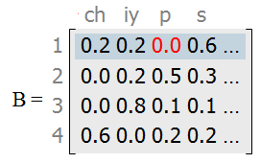

**(1) (3%) List the state transition probability matrix A:**

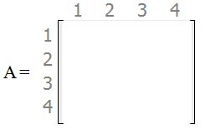

**(2) (3%) Convert the above FSM format to standard HMM graphical model:**

**(3) (3%) Provide the output probability P(X) formula (the following already lists the first 2 steps).**



=

**(4) (3%) Suppose the state sequence is " 1 2 3 3 2 ", and the corresponding observations are: "s p iy ch s". Solve P(X).**

**Q7. (5%) For a HMM, we have 3 most important problems such as model learning issue. Can you explain each of them in details?**

**Q8. (5%) The following is a Markov chain, not a HMM. What is the probability of seeing a sequence as "The little little girl"?**

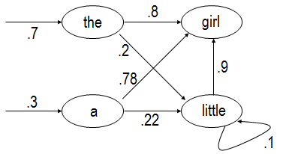

**Q9. (6%) Suppose we have N date points, X = { x1, x2, ... xN }. PCA firsts maps each point to the same direction (represented by an unit vector: u ). Then the point xn's mapping value is: uTxn .**

(1) (2%) What is the total variance of the projected data?

(2) (4%) PCA tries to maximize the above variance. It uses a Lagrange multiplier to consider the constraint uTu =1. Please deduce the PCA solution. (answer it on next page)

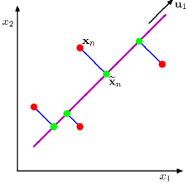

**Q10 (4%) What are the purposes of using PCA to process the data?**

**Q11 (5%) Explain the differences between supervised & unsupervised learning.**

**Q12 (5%) How do we use polynomial scheme to achieve curve fitting? List the polynomial function and the error function (called the least square function).**

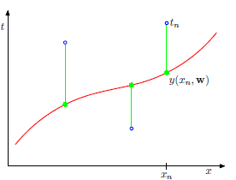

**Q13 (5%) What is called overfitting? How do we enhance the above error function to avoid this?**

**Q14 (6%) Now, use Bayesian method to achieve curve fitting. Assume the curve fits a Gaussian distribution. Deduce the Likelihood and Maximum Likelihood solution.**

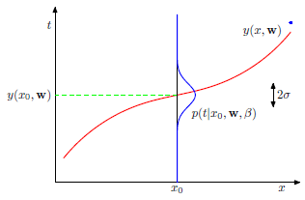

**Q15 (5%) Explain two important concepts in probability distributions: (1) sum rule; (2) product rule.**

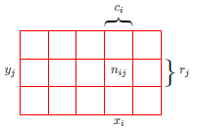

**Q16 (5%) Explain Bayesian Theorem.**



**Q17 (7%) Seek MAP (Maximum A Posterior) solution for curve fitting. Assume the prior probability of polynomial coefficients fits a distribution as:** 

**Q18 (5%) Explain Discrete Wavelet Transform from filters viewpoint.**