ECE 493/593 Tele-Healthcare Engineering

Lab 1 - Data Exporting via Physionet

(Fall 2012; Report Due Day: Sep 14, (Friday) 2012)

Report Requirements: There is no need to write a long report. Just capture a few screenshots in the report. The screenshots include:

* A figure that can show you have successfully installed WFDB Linux ToolKit (following the given installation guide);
* Two figures shown in the end of this document.

1. PhysioBank

PhysioBank lists all currently available databases, organized according to the types of signals and annotations contained in each database.

The link is given <http://www.physionet.org/physiobank/database/>

1. Export raw data
2. Go to the PhysioBank given above.
3. Choose the database which has the proper biomedical signals.
4. Download all three files (*.atr, .dat, .hea*) for one sample signal.
5. Export data with .mat file
   1. Use WFDB Linux ToolKit

For example, to convert record **mitdb/200**, use this command:

**wfdb2mat -r mitdb/200**

This works even if the input files have not been downloaded; in this case, **wfdb2mat** reads them directly from the PhysioNet server.

The output files are **mitdb/200m.mat** and**mitdb/200m.hea.** Note that if a subdirectory of the current directory named **mitdb** did not exist already, it would be created by **wfdb2mat**. In addition, if the standard output of **wfdb2mat** has been saved in a file named **mitdb/200m.info,** then the converted data can be read and plotted in Matlab or Octave from within the **mitdb** directory.

* 1. Use The PhysioBank ATM Toolbox

Go to link <http://physionet.org/cgi-bin/atm/ATM>

In the input, choose the signals that you want.

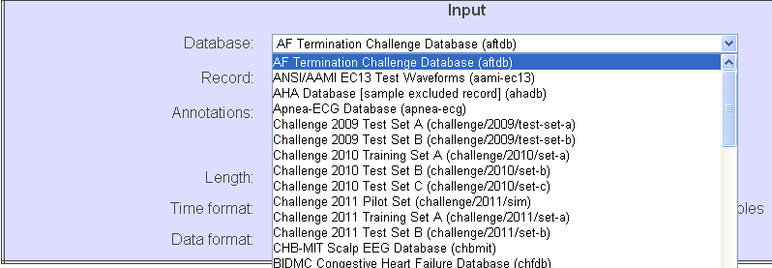

In toolbox panel, choose ***Export signals as .mat***

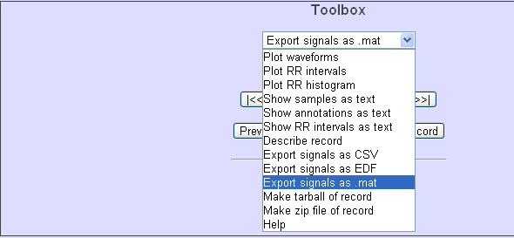

Then this toolbox would covert files for you automatically. Save all the files that converted for you in a folder.

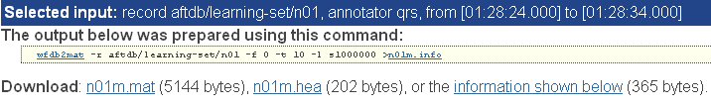

1. Run and plot the bio-signal in MATLAB

The MATLAB zip file is given which can run both two different data types.

The rddata.m and plotATM.m files are modified so that users can control input data.

* 1. First, choose the type of data that you want to input. 1 is *.dat*; 2 is *.mat*
  2. Then run the code to get the plot of signals and the outputs of data.

**Note:**

You have to download the files that you want in proper folders and change the ***path***, ***headerfile*** name, ***atrfile*** name, ***datafile*** name respectively. Also, users can control the length of input data.

1. Appendix:

The main MATLAB code:

%%%%%%%%%%%%%%%%%%%%%%%%%%%%%%%%%%%%%%%%%%%%%

% This program reads ECG data from both .data

% files and .mat files

%%%%%%%%%%%%%%%%%%%%%%%%%%%%%%%%%%%%%%%%%%%%%

clc; clear all; close all;

dataType = input('Please choose the type of data: 1-.dat; 2-.mat: [2]');

if isempty(dataType), dataType = 2; end

%%%%%%%%%%%%%%%%%%%%%%%%%%%%%%%%%%%%%%%%%%%%%

if dataType==1

%% ECG for 212 only

%------ SPECIFY DATA -------

path ='C:\Documents and Settings\Jiang\Desktop\Biomedical\Data\MIT_BIH'; % where data are saved

headerfile = '100.hea'; % header-file in text format

atrfile = '100.atr'; % attributes-file in binary format

datafile ='100.dat'; % data-file

samplelength = 600; % number of samples to be read

% in case of more than one signal:

% 2*samplelength samples are read

data = rddata(path,headerfile,atrfile,datafile,samplelength);

elseif dataType==2

%% find the data files in database index.txt in each database folder

addpath('Data\MIT_BIH');

datafile = 'slp01am.mat';

infofile = 'slp01am.info';

samplelength = 300;

data = plotATM(datafile, infofile,samplelength);

else

disp('Wrong dataType input!');

end



Fig.1 .dat datatype plot using rddata.m. The length of signal is 600



Fig.2 .mat datatype plot using plotATM.m. The length of signal is 300