PCB Artist Tutorial

Table of Contents

Installing the Software
To install the PCB Artist software, go to http://download.cnet.com/PCBArtist/ 3000-18496_410712335.html?part=dlPCBArtist&amp%3bsubj=uo&amp%3b tag=button and click the download now button. Once the download is complete, the software is ready to run.
Starting PCB Artist
During installation, a PCB Artist program icon is automatically added to your desktop and an Advanced Circuits program group is added to the Start menu and Programs. To start PCB Artist, simply double-click on the PCB Artist icon on your desktop or select the PCB Artist menu item.

Library Creation
PCB Artist is supplied with a set of libraries. These libraries can be used, modified and added to as required. You can mix and match new and existing library items together to create your own set of unique libraries. To insure the correct dimensions are used for the specific components, a new library with custom components is essential.
PCB Artist libraries are easy to understand and use once your grasp the basic concepts. The libraries are made up of three individual libraries. There is a Component library made-up of elements from the Schematic Symbol library and the PCB Symbol (footprint) library.
We only want to store a schematic symbol once and use it repeatedly in various configurations to produce different components. For instance, for the INA321 amplifier we have a PCB symbol library to store our 8-pin INA PCB footprint plus any other footprints and a Schematic symbol library for our amplifier plus any other Schematic symbols. These can then be used on their own or brought together (Schematic symbol & PCB symbol) in many different permutations to create a Component Library. We also have multiple Component libraries in PCB Artist to make the categorization of components clearer, these can be categorized by manufacturer, type, functionality etc.
You can create a new Schematic symbol and store it in the Schematic symbol library. But before you can use it in a design you have to create a Component for the symbol and store this in the Component library for use in your designs. Typically, this is how power and ground symbols would be defined for example.
Working this way, any Schematic Symbols you produce are stored with an appropriate name in the Schematic symbol library. It can then be reused multiple times to create different components using the manufacturer’s component name. Most components you produce will have the complete Schematic symbol and PCB symbol

Schematic and PCB Symbol Libraries
Two types of symbol libraries exist, those for Schematic symbols with the extension .ssl, and those for PCB symbols with the extension .psl. There is no limit how many symbols may be kept in a given library.
Creating Schematic Symbols
- To open the library manager
From the File toolbar, select the Libraries icon (shortcut Ctrl+L).

- To open the symbol manager
From the Library Manager dialog, select the Schematic Symbols tab.

For this tutorial, we will create a new library for each symbol/component type. You could of course, add your new symbols to an existing library.
The Symbol Editor will take a set of default design settings, such as Styles, Colors, Grids, Units, etc. These are taken from a selected Technology file. Once you become familiar with PCB Artist, you can customize these files using your own selections. If you click on the Tech Files button on this dialog, you will see how to choose this Technology file.
For now we will leave the defaults set to the ones supplied in the standard technology file.
We will create a new library in which to save the new symbol into. Click the New Lib tab.

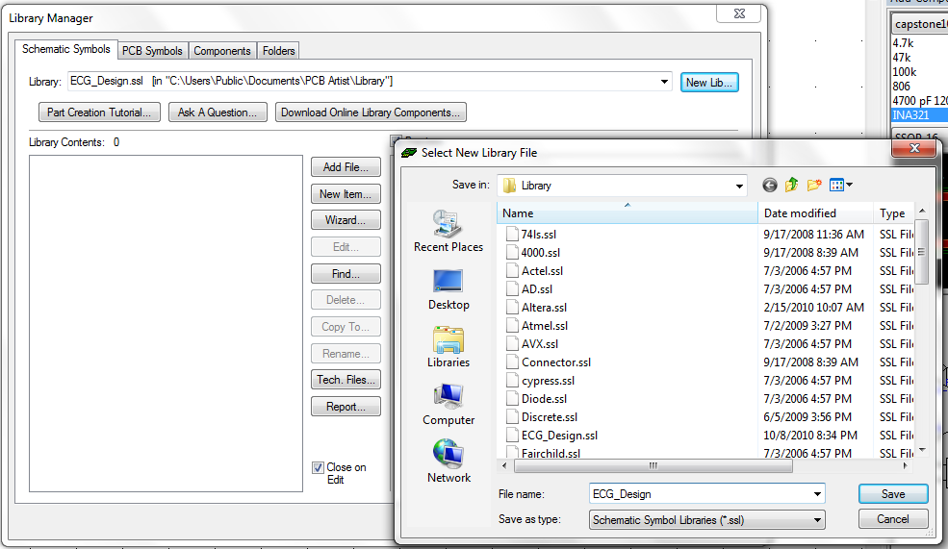

In the File name: box, type in the name ECG_Design. This will be the name of your new library.
Click Save to save this file name and exit the dialog.
The new Tutorial library is selected and is ready to have new symbols saved into it.
You need to create a new Schematic symbol so open the Symbol Editor using the New Item button.

For this tutorial exercise, we are going to create an instrumentational-amp component. The component will contain two symbols, both different. It will use an intrumentational-amp gate plus a power gate, we will do this to demonstrate using multiple gates for one component.
You will create the op-amp gate only, the power gate (PWR) already exists in the supplied libraries.
- Checking the screen dots
Firstly, zoom in (roll the mouse wheel or click the <Z> key) so you can see the Screen Grid displayed. The grid needs to be set to 50 mil so check this.
From the File toolbar select the Grids icon.

The Grids dialog is displayed.

Ensure the grid Step Size is set to 50 mil steps and click OK.
- Adding the symbol detail
On the Schematic Symbol toolbar (the vertical toolbar on the left side of the screen) select Add Shape (polygon).

Choose a starting point and create a shape 500 mil long moving down. The status bar at the bottom of the screen will show you the size being drawn.

Notice the Symbol origin point ‘S’ at the top left of the shape. We will move this later on to a more relevant location. This is always added to the original of the first symbol item added during creation. In order to get the triangle shape, you will need to take the editing mode out of Orthogonal and switch it into Free hand editing. To change to Free hand mode, click once to add a corner, 500 mil down (10 grid points) from the start point and then right click to display the shortcut menu. From the menu, select Segment Mode> and Free.

Now you can move the ‘floating’ second segment right 500 mil and up 250 mil to give you the point on the triangle. Because the grid is set to 50 mil steps you will be able to snap to 250 mils exactly.

- Adding the symbol detail
You may need a bit more space around the existing shape to add some additional shape detail. Use the pan function <P> on the keyboard or press the middle wheel button, or use zoom out or zoom in.
On the Schematic Symbol toolbar, select Add Shape Line.

Select a start point 100 mils down from the symbol origin ‘S’ on the vertical segment (2 grid points), drag a line 100 mils (2 grid points) to the left. Like this:

Use a single click to finish.
Add the additional lines required by selecting the line you have just inserted and clicking <Ctrl-C> to copy and <Ctrl-V> to paste. Do this twice. Of course you can always simply draw them in using the Add Shape Line tool as well. Your finished shape should look like the following figure.

- Adding pins
Pins need to be added to the Symbol to give PCB Artist ‘real’ electrical points on which to make connections. This gives PCB Artist its unique true electrical connectivity at all times.
On the Schematic Symbol toolbar, select Add Pad.

A pin will be available on the end of your cursor shown in the highlight color.
Position each pin on the end of the lines so that it looks like the example below. As each pin is positioned, the next one in the sequence is available on the end of your cursor.

You will see that these are auto-numbered as you proceed. After the last pin has been added, click the <Esc> key to cancel.
These pins must be sequential and for this example we will number them according to the picture shown above. In general, the sequence does not matter. They must also be unique and with no gaps in the sequence.
Click the <A> key to position the symbol to fit the window.
- Information on the pins
Each pin contains three pieces of information:
- The big cross marking the shape and location of the pin
- The Pin Number (1,2,3 etc.)
- The name position marker, N1,N2,N3,etc. which marks the location of the pin name when used on the Component in the design
The Pin name position marker (N3) will only be populated once the Component is used in the Schematic design, until then you only see the name position marker. This

You may also see the symbol origin ‘S’ character on Pin 1 if this pin was the first item to be added to the symbol (before the symbol shape).
The Pin Number is then automatically numbered. This can represent the actual terminal number if required but can be renumbered in the Component definition. The number is shown in the position it will appear in when used in the design. This can be moved in the Symbol editor but cannot be moved once placed in the design.
- Moving the symbol origin
The Symbol origin is the Symbol’s reference point used when moving it in the Schematic design (the small ‘S’ marker). For consistency we always try and place this in the same relative location, usually on Pin 1 of the symbol.
The symbol origin would have been added with the first design item. In our example, this was the symbol shape but it could have been the first pin added.
Select the origin on the symbol and drag the symbol origin to Pin 1 as shown below.

- Moving Pin names
Select and drag the pin numbers (pins 1, 2, 3, 4, 5 and 6) and pin names (pins N1, N2, N3, N4, N5 and N6) and move them into the required location making sure only the name is selected and not the pin itself (the big X).
To make sure the positioning of pin names and numbers easier and more refined, during the move, use the shortcut keys <Ctrl+G> to display the snap mode. Change the snap to a Half Grid or Quarter Grid.
Position the pins to look like this:

- Adding the reference origin
Without a Reference Origin, the component name (U1, IC1, etc.) used in the Schematic design will automatically be placed on the Symbol Origin. By adding a specific Reference Origin you can position the Component name where you like.
By default, the PCB Artist libraries have the Reference Origin placed at the bottom right side of the Symbol shape.
To add the Reference Origin, select Reference Origin from the Add menu.

Place the ‘R’ marker on the Symbol.

When the Symbol is used with the component in the design, the Reference Origin is also used for positioning the Component Name, Package Name and PCB Symbol Name if these items are selected as displayed.
You are now ready to save the symbol into the library.
- Saving the symbol
From the File menu, select Save.

The Save dialog opens.

Choose the ECG_Design.ssl library and give the symbol and the name ina, click OK.
- Viewing the symbol in the library
Now that the symbol has been created and saved, let’s view it in the library manager.
From the File toolbar, select Libraries, you can also use the <Ctrl-L> shortcut key.
The Libraries dialog opens. Select the Schematic Symbols tab if it isn’t already selected and select the Tutorial.ssl library from the drop down list.
Ensure the Preview box is checked.
From the Library Contents: list, select the INAMP symbol that you’ve created, it should look like the one below:

Once you are satisfied with this, move onto the next section to create a PCB Symbol (footprint).

Creating PCB Symbols (Footprints)
- Start the Library Manager
From the File menu, select the Libraries icon (Ctrl+L)

- To open the symbol editor
From the Library manager dialog select the PCB Symbols tab

For this tutorial we create a new library to add your new PCB Symbol to.
Click the New Lib button.

In the File name box, type ECG_Design as your new PCB symbol library. Click Save to accept this. The library manager is now ready to start entering new PCB symbols.

- To Start the PCB symbol wizard
For this tutorial, we will us the PCB footprint wizard. For footprints that need calculating dimensions for, this is the easiest way to create them. Since the ECG board is an extremely small and design specific board, this step should be done for each individual part on the schematic and PCB board.
From the Library Manager window, click the Wizard button. Ensure that you are on the PCB Symbols page.

- The Footprint
For this tutorial, we will design the PCB Symbol for the INA321. The manufacture’s datasheet, which can be found at http://focus.ti.com/lit/ds/symlink/ina321.pdf, provides us with footprint pattern dimensions. The footprint, from the datasheet, is shown below.

- Using the footprint wizard
Click the Wizard button.
From our example footprint shown above, the other aspect you’ll notice is how exact the range of dimensions is. This exactness also gives you a level of vagueness as you need to know how the footprint will be manufactured before being able to complete it.
The first page you are presented with is Start.

Click the Next> button to move forward and start the new symbol. Across the bottom of the page are always located the <Back, Next>, Cancel and Help buttons, which may be used at any time during the wizard.

The next page is used to choose a possible Technology file and the Units to be used.

No technology file will be used. We will change the Units to Metric and the Precision of 2. We will use a precision of 2 because our datasheet measurements are within that same precision. Our footprint is very small and will require a pin pitch of .5mm.
The preview pane (shown on the right in the Footprint Type window) will display a symbol. This symbol is a graphical representation of the current shaped and differ depending on the component you are designing.
Click Next> to move on.
On the type page, select the SOIC shape. Your preview will now change to represent a SOIC device.
On Origin, select Center. Since the ECG board has such tight space requirements, all components for the ECG PCB design will be surface mount. For a surface mount (SM) component, having the Origin at Center is normal.
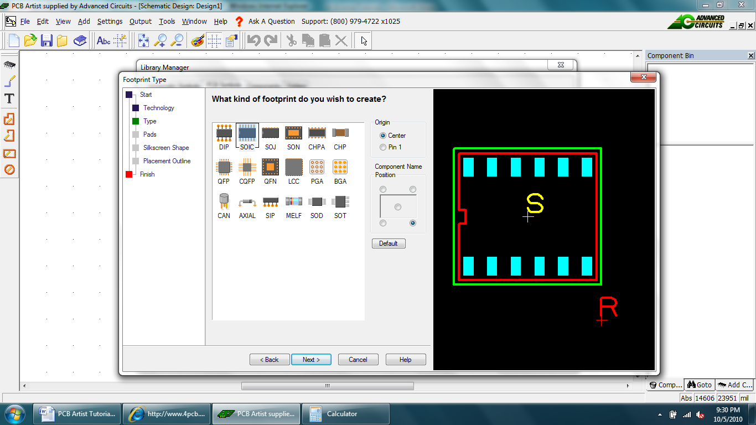
For Component Name position, click the bottom right radio button. You’ll see the preview update.

Click Next> to move on.
The Pads page is used to define the overall footprint layout. This is probably the most important page of the wizard. The default page setup is shown below, we need to change the parameters defined here.

From the given datasheet, observe that the INA321 has 8 pins. Since the INA321 has 8, the Pad Count should be set to a Total of 8. You can use the spinner or type in the number to change it. You must type in the name of the pad Style that will get saved once you’ve edited the dimensions. Use Rectangle for the specific pad style.

In Measurements, you need to enter the dimensions to be used. These dimensions are located on the datasheet provided, or you can find it at the Texas Instruments link provided: http://focus.ti.com/lit/ds/symlink/ina321.pdf. The correct dimensions have been highlighted for our footprint; all are in mm.

e | 0.65
E | 4.90
PW | Automatically calculated
PL | Automatically calculated
L | 0.55
T | 0.05
H | 0.05
b | 0.32

You must now choose the position for Pin 1 to be the bottom left corner, to Hide Pin Numbers and the Pin Numbering to be Counter-clockwise.

Click Next> to move on.

You should now define the Silkscreen outline.
This dialog is setup by default to assume you will always require a silkscreen outline. The only parameter to change here is the Notch At End value, change this to 0.50.

Click Next> to move on.

We will use the placement shape and add it to the Documentationa1 layer. Select this layer from the drop down list.

Click Next> to move on.
In the Footprint Name: box, type INA321.
Check the Save the footprint to the library box.
Select your ECG_Design.psl library from the drop down list.
Leave the Edit the footprint now check box unchecked.

Click Finish to complete the footprint creation.
- Viewing the symbol in the library

Now that the symbol has been created and saved, let’s view it in the library manager. From the Libraries button on the File toolbar, select Libraries, shortcut key <F11>. Select the newly created footprint from the contents list (INA321). Check the Preview box if not already selected so you can view the footprint. You can also edit it from here as well.

The footprint is now ready to be used in a component.

Creating Surface Mounted Footprints
Surface Mounted pads of the PCB Symbol are easy to create, and will be necessary for most of our ECG components. The only consideration needs to be for the side that the pads reside on. For normal pads, this would be the [All] layer. This means that the pad occupies all of the layers in the design. Whereas a surface mounted (SM) pad would only occupy the outer layers [Top] or [Bottom].
All surface mounted pads are defined on the Top layer. When used in the PCB design, the component is flipped to the other side of the board (Bottom). For the ECG PCB design, all components will be mounted on the top layer of the board.
- Change the layer of the pad

During the addition or once the pad has been added, the layer can be changed. You may also find that you need to change the pad style as well.

Select the pad(s) and right click. From the menu, select Change Layer <L>.

Select the New Layer from the drop down list. The Old Layer: box will display the current layer used.

An alternative method is to use the Pad Properties, also on the shortcut menu.

The Layer: drop down list will contain legal layers for which to swap your pad to. You should be aware that there may also be a Pad Style change required, especially to note is a drill hole and plated status of the current pad style.
Click OK to accept the change.

Creating Components: Using the Component Editor
This tutorial uses the Schematic Symbol and PCB Symbol (Footprint) created in the previous tutorials, but equally applies to creating a component using other Schematic Symbols and PCB Symbols.
- To open the Component editor
On the File toolbar click Libraries <F11> or <Ctrl+L>.

From the Library manager select the Components tab. For this tutorial, we will use the same library we have used for our Schematic Symbol and PCB Symbol (Footprint).

Click the New Lib button.

In the File name box, type ECG_Design as your new component library.
Click Save to accept this. The library manager is now ready to star entering new componenets. We need to create a new component so cline on New Item. The New Component dialog box opens. There are 8 pieces of information required:
- In the Component: box type the component name INA321
- In the Package: box type SOIC, this identifies the package type, multiple package types can be used for selecting alternative footprints.
- In the Default Reference: box type U. This will be the component name used in the actual design (or seen on the silkscreen of the PCB)
- For Schematic Symbol, ensure that the library is set to ECG_Design.ssl. Select your Schematic Symbol previously created ina from the list.
- The dialog will automatically show Pins: as 6 and Gates: as 1. Change the Gates: to 2. This will add another to the component.
- For the PCB Symbol, ensure that the library is set to ECG_Design.ssl. Select your PCB Symbol previously created INA321. Ensure that the Pins box shows 8 to verify that you PCB Symbol is correct.
- Your diaolg is complete and should look like the one below:

Once it does, click OK to continue.
The Component Editor opens showing the items added from the New Component dialog.
The Component Editor now looks like this:
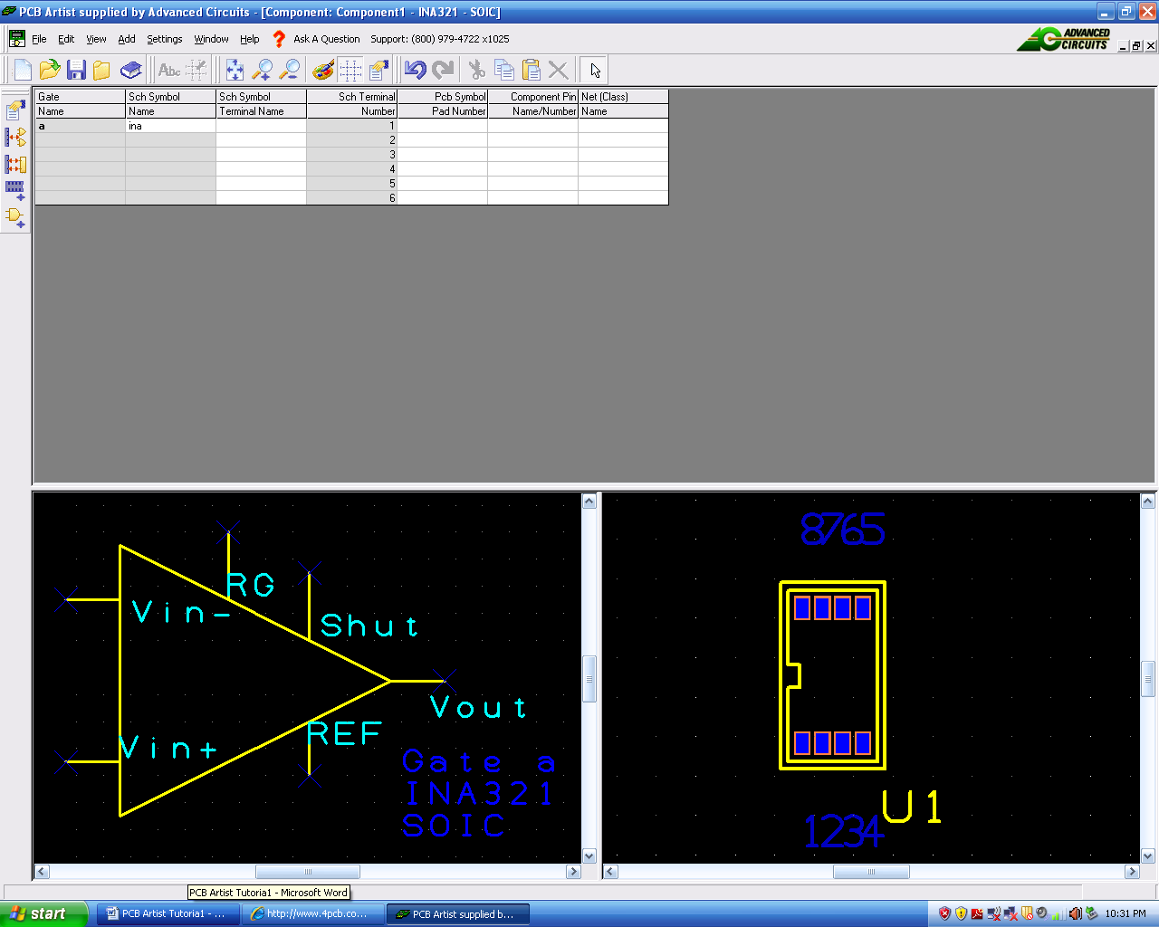

So far we’ve given the Component a Name, selected the name default reference name stem to be used and selected the Schematic and PCB Symbols to be used. We now need to add more detail to the component to give it more intelligence.
- Adding an extra gate
We need to add a power gate to the component. There are various methods in PCB Artist to adding power and ground to the component, for now this is one of the easiest.
Right click anywhere in the component grid. From the list, select Edit Gates.
From the Gates dialog, select the Add button. Notice your existing 2x OPAMP gates are already shown in the list as gates a & b.
From the Library: list select the AD.ssl library.
Scroll down the Name: list and select the AD-P2 gate symbol. Ensure that you only have 1 selected in the Add 1 Gates box. Click the Add button.

The Power gate will appear at the bottom of the list. Click OK to add it to the component.
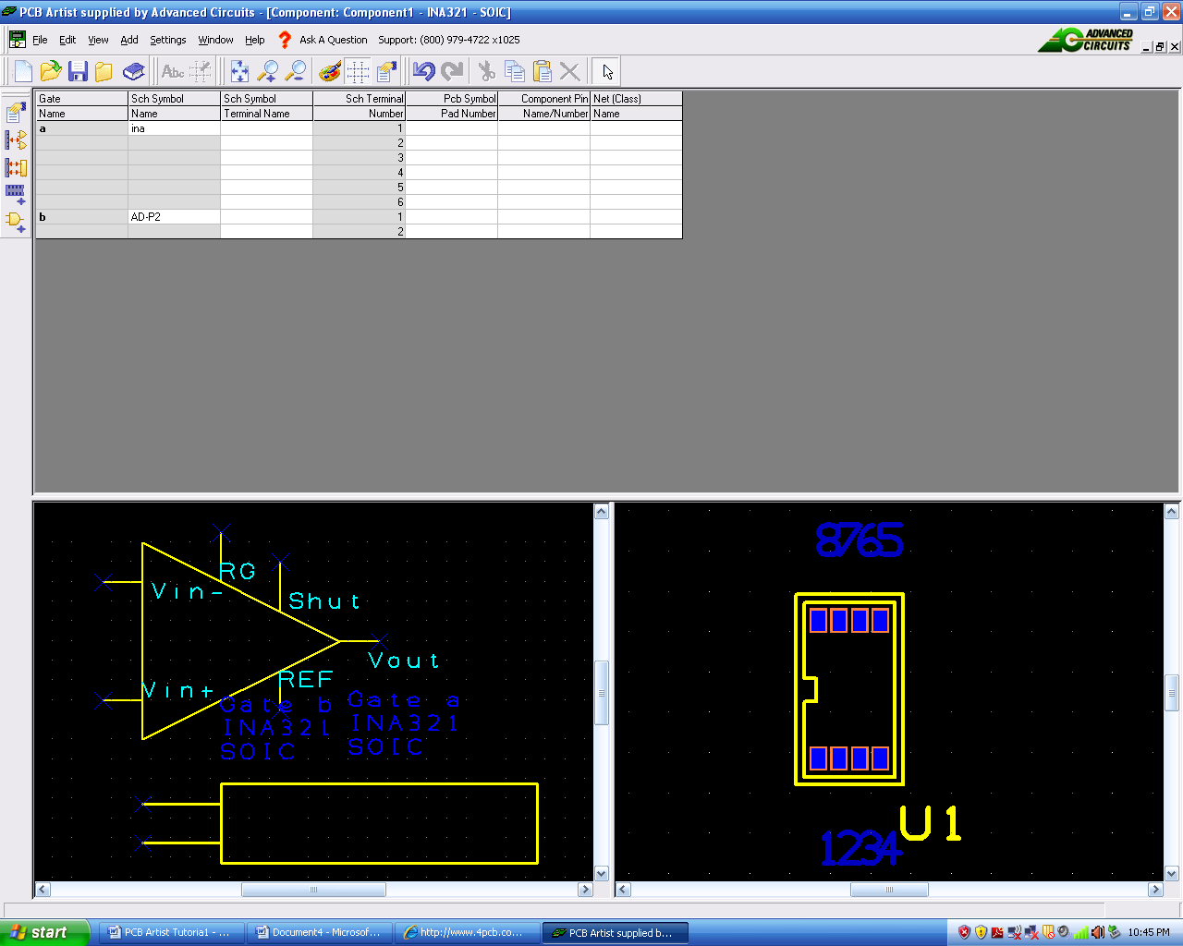

The power gate will now appear at the bottom (as the last gate) in the component grid and in the Schematic Symbol preview.
Now we need to add more detail to the component and to ‘map’ the pins used in the
Schematic Symbol to those that will actually be used in the PCB Symbol.
- Mapping pins to pads – why?
For a Component to work, it needs to know how the pins defined in the Schematic Symbols relate to the pads used in the PCB Symbol. This mapping is presented in a ‘grid’ format in the component editor.
You can map the pin relationships manually or automatically by using the tools provided. On complex devices like a 256 pin BGA, the automatic method may be more preferable than the manual method which may be better for resistors for example.
You can use three methods: you can directly type the pad numbers into the respective grid cells or you can use the Assign Pins modes that let you click on the Schematic Symbol pin first and then the equivalent PCB pad. You also have the Assign Pins 1:1 which automatically assigns pins on a 1 to 1 basis, Schematic to PCB symbol.
- To map pins to pads
Generally speaking, you will use the Assign Pins method most times to do this task. This enables you to manually click on the Schematic symbol pin and then the corresponding PCB pin.
Click on the Assign Pins button on the Component toolbar.

The natural pin mapping of the Schematic Symbol and the PCB Symbol during creation will not be the same and will not necessarily be the correct sequence for mapping. PCB pins generally drive the mapping. However, for this specific example, we have considered the number sequence of the Schematic Symbol during the creation, which allows us to follow more closely the PCB pin sequence.
Consider the component and schematic symbol shown below. We will number our pins according to these pictures.

Select Pin 1 on the Schematic Symbol.
Select Pad 1 on the PCB Symbol.
The component grid will display the number 1 for Sch Terminal Number 1 on gate a, it will also display a number 1 in the corresponding Component Pin Name/Number cell.
As you see, we have chosen to map the first pin on the Schematic Symbol to the first pin of the PCB Symbol because they correspond to each other. Map the other pins accordingly.
Once assigned, a number 1 will be shown on the Schematic Symbol output pin (pin 1). The color of the Schematic Symbol and PCB Symbol pins will also change color to reflect this. A different color will be shown for assigned and unassigned pins, and the currently selected pin.
You should complete all pin to pad mapping so that looks like this:
With the assignment of all pins between the Schematic and PCB symbols, this would be considered a minimum configuration to be able to save the component to the library and then use it in a design. Other information can be added and is discussed below after saving the component.
- Saving your Component
From the File toolbar, select Save <Ctrl-S>

The Save To Library dialog opens.

Choose the ECG_Design.cml library from the list if not already selected.
You entered the Component editor through the New Item dialog and have already given the component a name. This name will be displayed.
Click OK to confirm the library name and component name. You have now saved the Component in the Library. The component will still be visible in the editor. We will edit it some more so keep it open for now.
- Viewing the Component in the library
From the File toolbar, select Libraries, <F11> or <Ctrl-L>
The Libraries dialog opens. Select the Components tab if it isn’t already selected.
Make sure the Preview box is checked.
Select the INA321 Component that you created, it should look like the one below.

A quick check to see whether you have created is correctly is the existence of both the Schematic and PCB Symbols in their respective Preview windows.
At this stage, you would add this component to a Schematic or PCB design and it would work.
Creating the Rest of Your Components
The rest of the components, with the exception of the OPA4336, are very simple to create. The Schematic Symbol for both the resistors and capacitors do not require designing, they can be added from the Discrete.ssl schematic library, using the Add File button in the Schematic Symbol window.
The PCB Symbol does require using the Wizard. This allows you to design each resistor and capacitor to the size of the actual component that you will be ordering. For further help go to the PCB Artist Library Creation Tutorial, which is located at the following web address: http://www.4pcb.com/downloads/pcbartist/PCBArtistLibraryTutorial.pdf

Schematic Design Tutorial
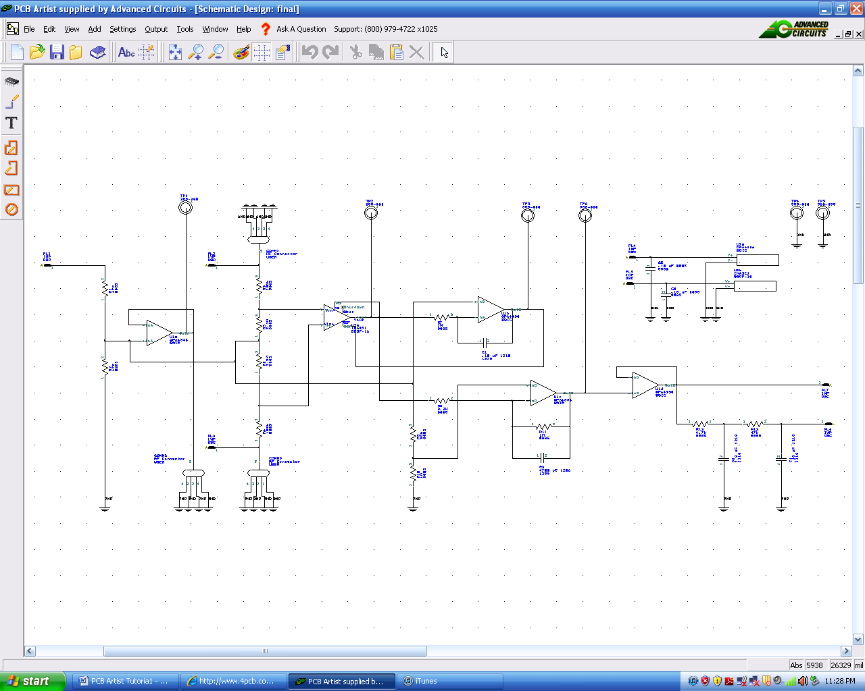
Fortunately, the Schematic from which the ECG PCB Design will be made has been supplied to us by Dr. Fei Hu. Open the file from the extension you have it saved at. Your PCB Artist window will look like this ready to start:

The next stage is to convert the design into the PCB design environment
Although we will not cover how to create this schematic in this tutorial, there is some useful information located in the PCB Artist tutorial, which can be found at the following web address: http://www.4pcb.com/downloads/pcbartist/PCBArtistTutorial.pdf

Converting the Schematic to PCB
If you created a Schematic in PCB Artist, the final process before starting on the PCB design itself is to translate the Schematic design into the PCB design editor.
When you are in a position where you wish to go-ahead with this translation you should select Schematic <- - > PCB > and use the Translate To PCB option from the Tools menu.

This will display the New PCB wizard.
Starting a New PCB Design
You do not have to create a PCB design from a Schematic design. If you intend starting a new PCB design without using a Schematic design first, from the File menu select New and check the New PCB Design radio button. Click the OK button and this will start the New PCB Wizard. However, we already have our Schematic design, and will definitely be creating our PCB design from this.
Getting Started with the Design
PCB Artist PCB is flexible in that you can start your layout in two ways:
- Use PCB Artist Schematic Capture as the 'front-end' to the PCB system. The nets and components are converted to PCB in the integrated environment.
- Use the PCB Artist PCB design editor interactively creating the design on-the-fly without the need for an initial netlist. You just add components and connections as required to create the PCB design.
Converting the Schematic to PCB
If you are following the tutorial, you would have already processed your ‘logical’ Schematic design into the ‘physical’ PCB design layout editor using the Schematic To PCB wizard. If you didn’t do this, go back to the previous chapter (Chapter 3 - Converting your Schematic to PCB) and convert your schematic into a PCB design.
At this point you are ready to start laying out the PCB design. You will see the board outline ready to place the components in. We previously chose to leave the components unplaced and the nets unrouted. These two features can both be selected during the final conversion process.

Adding Components
- To add a component
There are two methods for adding components; we will use the Interaction bar to start with, you can also use the Add Component option as well. The Interaction bar can be displayed by clicking the <F9> shortcut key.

Select the Add Component browser tab at the bottom of the Interaction bar.

From the list of available libraries, select the ECG_Design library. Click on the small down arrow to reveal the drop down list and then make the selection. Notice, in this list, all the required components to design the schematic have been made. As said in the last part of the Creating Components tutorial, you will have to make these parts on your own.

What’s left:
- Mapping the Pins to the correct pads so the functions of each gates are correctly defined
- A brief statement to address using these three steps to create all of the components and using them to create a PCB design
- Wiring and layout issues:
  - Making sure the pad is 20 mils larger than actual component
  - No 90° angles for the wire routing
  - Advantages of having an entire ground plane/layer
  - Others?
- How to verify?

